DISCOVER PERU # 30
12 Days / 11 Nights

Lima, Amazon Adventure near Iquitos, Arequipa, The Colca Canyon, Cusco,
Machu Picchu, Pisac Indian Market and Ollantaytambo Fortress

Day-by-Day Itinerary

Day 1 – Tuesday - Lima - Arrival  Arrival in Lima, the "City of Kings" famous for its Spanish Colonial architecture, extraordinary museums and cuisine. Lima is internationally recognized as the "Gastronomic Capital of the Americas", and its cuisine is considered among the most diverse and exquisite in the world on par with French cuisine. Upon arrival a host will meet and assist you in transferring to the hotel and in registering. | 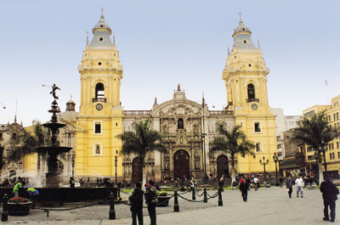

Lima City Tour and Gold Museum  Tour of Modern and Colonial Lima including the Gold Museum - This half-day tour visits both the colonial and modern sections of Lima. Colonial sites include the lovely Plaza Mayor, the Government Palace, San Francisco Church and the exquisite Torre Tagle Palace modern day seat of the Ministry of Foreign Affairs. In modern Lima, drive along the exclusive residential areas of Miraflores and San Isidro. | 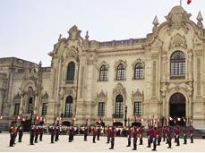

Continue to one of Peru’s most famous museums, the Gold Museum houses a priceless collection of pre-Columbian gold artifacts as well as the private armory of Miguel Mujica Gallo. Some of the cultures represented in this collection include the Chavin, Paracas, Nazca, Tiahuanaco and Inca. During the guided visit you will see not only intricate gold pieces, but also wood, textile and shell artifacts that represent some of the most basic daily activities of these important civilizations. | 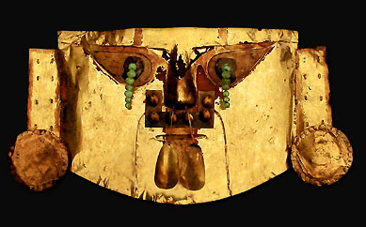

Day 2 – Wednesday - Flight to Iquitos, on the Amazon River (B,L,D)  Transfer to the airport for your flight to Iquitos on the shores of the legendary Amazon River. This region is covered by dense vegetation and by primary and secondary jungle with low hills and slightly rolling landscape, crisscrossed by the many rivers of the Amazon River basin, which is born at the confluence of the Marañon and Ucayali Rivers. | 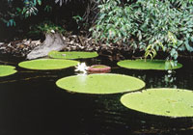

Transfer to the Explorama dock. Twenty-five mile journey down the Amazon River to Ceiba Tops where private rooms with air conditioning and hot water provide all of the comforts of home. Afternoon hike in the beautiful primary rainforest reserve surrounding Ceiba Tops which includes many huge trees festooned with epiphytes. After dinner there may be local flute or guitar music at the El Toucan Bar or the guides are always ready to relate some of the many legends of the Amazon forest.  Overnight Ceiba Tops. | 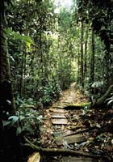

Day 3 – Thursday - Ceiba Tops (B,L,D)  Morning boat ride, spotting for dolphins, to visit a small village of Yagua Indians where your guide will explain the Yagua Indian culture and how it was affected by the arrival of Europeans and the passing of time. There will also be an opportunity to see some of the local crafts and for a demonstration of the blowgun which some of the Yagua elders still use for hunting. Afternoon walking excursion to the neighboring town of Indiana stopping along the way to see the immense Ceiba tree for which the lodge is named. Originally a Franciscan mission, Indiana has grown into a large river community with its own market, high school and small hospital. Overnight Ceiba Tops. | 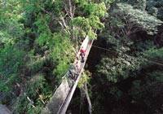

Day 4 – Friday - Ceiba Tops / Iquitos / Lima (B)  Early morning departure by boat from Ceiba Tops to Iquitos followed by transfer to the airport for your flight to Lima.  Due to the ever-changing nature of the rainforest, day-by-day activities may vary due to local conditions. | 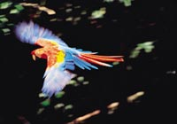

Day 5 – Saturday - Lima / Arequipa (B)  Transfer to the airport for your flight to Arequipa at an elevation of 7,300 feet. Upon arrival a host will meet and assist you in transferring to the hotel and in registering.  Also known as the "White City" for its many constructions built of white volcanic stone, Arequipa is at the foothills of the Misti Volcano (the guardian of the city) and it has a splendid Cathedral that is considered one of the first seventeenth century religious monuments of the city. | 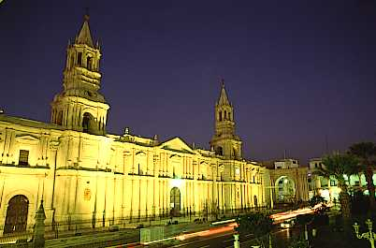

Arequipa City Tour and Santa Catalina Convent - Your half day sightseeing of this beautiful city, placed on the World Cultural Heritage list by UNESCO, features Mixed Baroque churches and mansions from the colonial period like the Monastery of Santa Catalina, The Main Square is bordered by various arched walkways and the Cathedral, it showcase a beautiful bronze fountain of three plates crowned by the figure of a sixteenth century soldier. Around the square, you see three granite portals with brick and lime bases. | 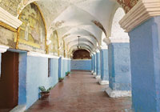

The Santa Catalina Convent is called "a city within a city", a Spanish city in miniature with stone streets, beautiful patios, and plaza, it is a masterpiece of colonial architecture, and houses some of the finest examples of Spanish American religious art. Since 1970 visitors have been able to stroll through the streets and cloisters that during colonial times were the refuge of female nobility who had decided to isolate from the world and dedicate entirely to prayer. | 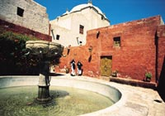

Day 6 – Sunday - Arequipa / Colca Canyon (B,L,D)  Departure towards the highlands passing through Yura-Pampa Cañahuas and La Pulpera with good possibility of observing groups of wild vicuñas and fighting cattle. The road to the Colca Canyon reaches a high point of 13,000 feet before dropping down to the valley, an area of breath taking landscapes surrounded by terracing and snow-capped peaks. Far below, at a depth of 10,000 feet, the Colca River winds along the bottom of the canyon, the world's deepest. | 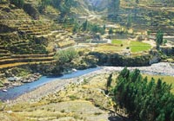

Stop en route to see petroglyphs in the Caves of Mollepunco and in the town of Callali to see natural hill formations with the appearance of enchanted castles. Continue to La Calera to enjoy the thermal baths under the stars.  Overnight in the Colca Canyon area | 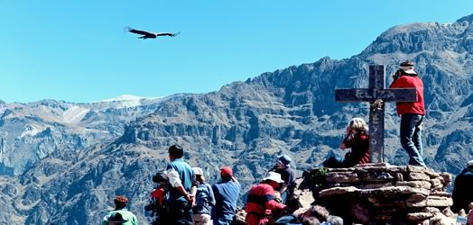

Day 7 – Monday - Colca Canyon / Arequipa (B,L)  To maximize your probability of seeing condors we depart very early towards a superb natural lookout point “Cross of the Condor” from where one can watch condors wheeling across the Colca Canyon, at about an altitude of 15,000 feet. The valley also features pre-Inca ruins, pre-Inca burial grounds and archaeological remains left behind by the Collagua, the ancient inhabitants of the area. Drive further in to the canyon to observe the way of life in this remote land and to admire the impressive irrigation system and the fertile mountains terraced for farming of the Colca valley. | 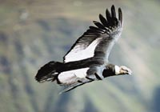

Ask your guide to take you to one of the many workshops in which close to a thousand artisans, scattered throughout the towns in the canyon, turn their ancient sewing and weaving machines into paint brushes to give life to impressively intricate and colorful embroidery and shawls.  Afternoon return to Arequipa. | 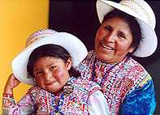

Day 8 – Tuesday - Arequipa – Cusco (B)  Early morning transfer from the hotel to the airport for a short but spectacular flight over the snowcapped Andes to the oldest inhabited city in the hemisphere, Cusco, at an elevation of 11,440 feet.  Upon arrival a host will meet and assist you in transferring to the hotel and in registering. | 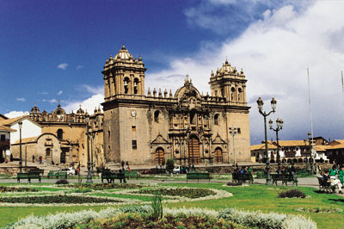

Tour of Cusco and Nearby Ruins – Visitors are caught up in the excitement of touring the ancient capital of the Inca Empire, a delightful combination of Inca and colonial architecture. The tour visits important landmarks such us Cusco's Cathedral, Plaza de Armas and Koricancha “The Temple of the Sun”. This tour of the oldest continuously inhabited city in the western hemisphere also includes the nearby ruins of Kenko, Puca-Pucara, Tambomachay as well as the Sacsayhuaman fortress, an imposing example of Inca military architecture. | 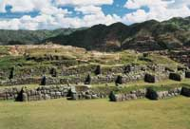

Day 9 – Wednesday - Machu Picchu (B,L)  Morning train ride through the sacred valley of Urubamba to the "Lost City of the Incas," Machu Picchu. Perched 8,200 feet above the valley, it was hidden by mountains and semi-tropical jungles for 400 years until discovered by Hiram Bingham of Yale University in 1911. Archaeologists believe that the Inca "Virgins of the Sun" took refuge from the Spanish Conquistadors here. Guided tour of the ruins upon arrival. Lunch is at the Orient Express’ Sanctuary Lodge located just a few steps from the Inca citadel. | 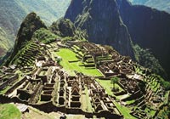

Day 10 – Thursday - Pisac Market and Ollantaytambo Archaeological Complex (B,L)  Full Day Excursion to the Pisac Indian Market and the Ollantaytambo Fortress - Morning departure for a drive through the fertile countryside of the Urubamba Valley to the colonial village of Pisac where a unique Indian Market takes place daily. The variety of products offered is overwhelming, from pottery with reproductions of archaeological pieces, to all kinds of textiles, jewelry and Peruvian handicrafts. During your visit to this bustling marketplace you will have the opportunity to bargain with the artisans and indigenous traders. Grab the items you like, you will hardly see the same one again. | 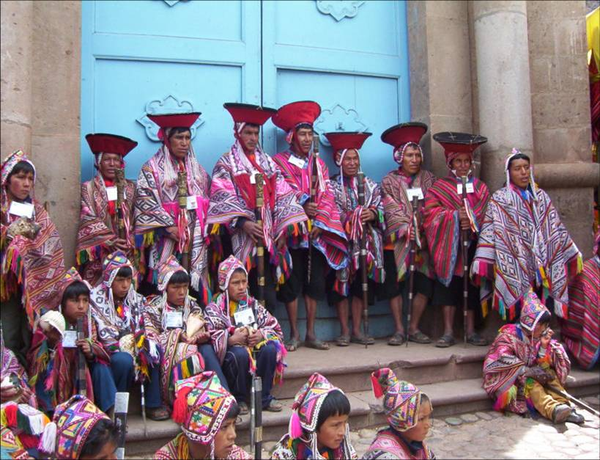

Continue to the Ollantaytambo archaeological complex, the Incas built it as a fort that included a temple, agricultural terraces, and an urban area. There are two distinct sectors: The religious and worship zone, and the residential area. Ollantaytambo was an important administrative center with probable military functions if one considers the walls and towers. There are also traces of ancient roads and aqueducts. The town of Ollantaytambo is called a "Living Inca Town" since the inhabitants maintain very old practices and customs. Lunch is at a beautiful country estate on the shores of the Urubamba River. | 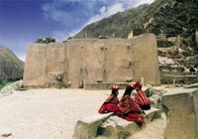

Day 11 – Friday - Cusco – Free Day (B)  Wandering through this lovely city, exploring the astonishing narrow streets of this tile roof colonial town will be your unforgettable experience. You will find something astounding at every turn. Great buys are the traditional Peruvian handicrafts, alpaca-wool sweaters and rugs, ponchos, pottery, gold and silver jewelry, leather goods, etc. Because there are such a variety of products, we strongly suggest that when you like any particular item, you should buy it - you may not find the same item in other store. Many visitors to Cusco return home wishing they had a free day to discover this imperial city on their own, a free day in Cusco is a MUST! | 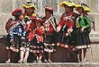

Day 12 - Saturday – Cusco – Lima – Home (B)  Transfer to the airport for your departure to Lima and your connecting international flight. Arrive home full of great memories of the rich tradition of Colonial Lima and the mystical Land of the Incas. | 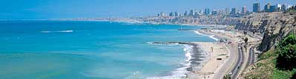

   End of Services   

Tour includes:
● All airport transfers listed in the itinerary
● Baggage handling at airports and at hotels
● All tours and excursions indicated in the itinerary
● All entrance fees and transfers needed to operate tours and excursions
● All train tickets, bus tickets and boat services needed to operate tours and excursions
● Excursion to Machu Picchu is aboard the Vistadome Train.
● Lunch in the excursion to Machu Picchu: Lunch at Sanctuary Lodge
● Service of a bilingual licensed tour guide for all tours and excursions
● All meals indicated in the itinerary. B for breakfast, L for lunch. D for dinner
● Hotel accommodation and hotel service charge
● Hotel taxes are exempt for foreigners visiting Peru
● When domestic airfare within Peru is specified as included: Airfare includes all queues, security fee, fuel surcharges and 18% Peruvian sales tax.

Not included:
● Extra expenses in case of modifying the itinerary due to flight cancelation, strikes or blocking of roads and train tracks by demonstrators or political activists. Travel insurance is strongly recommended.
● When staying overnight in Machu Picchu, the entrance fee for the 2nd day in Machu Picchu is not included. This can be added to the itinerary upon request
● Expenses such us beverages on meals, tips, laundry, phone calls and other personal expenses are not included
● When a cruise to the Galapagos Islands is part of the itinerary, the Galapagos National Park Tax is not included. It is payable upon arrival at the Galapagos Islands

Cancelation Penalties for FIT’s
● The cancellation penalty is 100% when services are cancelled within 30 days of arrival.
● When the deadline to cancel without penalties is longer than 30 days, Fiesta Tours Peru will notify you upon confirmation of services.
● Amazon river cruises and Galapagos island cruises are not refundable when services are cancelled within 90 days of arrival. When deadline changes, clients will be notified.

General Conditions for Groups
● Rooming list is due 50 days prior to arrival ⁽¹⁾.
● Payment is due 50 days prior to arrival.
● An updated number of rooms to be needed is recommended 90 days prior to arrival.
● Hotels’ cancellation penalty will be provided upon confirmation.
● Transfers and tours have a 100% cancellation penalty for services cancelled within 30 days of arrival.
● Airfares have a 100% cancellation penalty for flights cancelled within 35 days of departure.
● Inka Terra Hotels requires a 20% non-refundable deposit 95 days prior to arrival. They reserve the right to request a 20% non-refundable deposit at any given moment. Final rooming list is due 65 days prior to arrival.
⁽¹⁾ The following hotels will require the final rooming list 65 days prior to arrival: Belmond Hotels, J.W. Marriott and Gran Hotel Faraona. ^{V-Apr-15-2014}

Please review our General Conditions
http://www.fiestatoursperu.com/gcenglish/

    

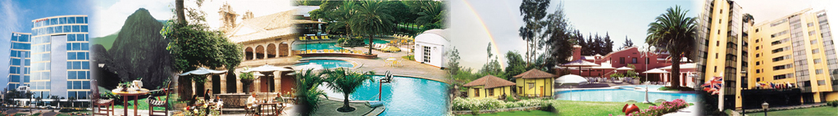
Hotels used in Tour Packages: For Discover Peru Series – 2023
City | Tourist | Tourist Superior | First Class | First Class Superior | Deluxe | Luxury
Lima | Arawi Miraflores  Express | El Tambo  Peru #2 | Arawi Miraflores  Prime | Dazzler By Wyndham  Lima Miraflores | Hyatt Centric  San Isidro | Miraflores Park,  A Belmond, Lima
Cusco | Terra Andina  Colonial Mansion | Terra Andina  Colonial Mansion | Xima Cusco Hotel | Sonesta  Hotel Cusco | Palacio del Inka  A Luxury  Collection | Monasterio,  A Belmond Hotel,  Cusco
Valle Sagrado | Ava Spot | Villa Urubamba | San Agustín  Monasterio  de la Recoleta | Sonesta Posadas  del Inka Yucay | Tambo del Inka  Luxury Collection  Resort & Spa | Río Sagrado,  A Belmond Hotel,  Sacred Valley
Aguas  Calientes | Flowers House  Machu Picchu | Casa Andina Standard  Machu Picchu | El Mapi Hotel | El Mapi Hotel | Inkaterra  Machu Picchu  Pueblo | Sanctuary Lodge,  A Belmond Hotel,  Machu Picchu
Arequipa | Casa Andina Standard  (Hab. Tradicional) | Casa Andina Standard  (Hab. Superior) | El Cabildo  Hotel | Casa Andina  Select Arequipa | Costa del Sol  Wyndham Arequipa  (Hab.Junior Suite) | CIRQA - Relais  & Châteaux  (Hab. Claustro)
Colca | Casa Andina  Standard Colca | Casa Andina Standard Colca | Aranwa Pueblito  Encantado  del Colca (Hab.Deluxe) | Aranwa Pueblito  Encantado  del Colca (Hab.Deluxe) | Aranwa Pueblito  Encantado  del Colca (Hab.Suite) | Las Casitas, A Belmond  Hotel, Colca Canyon  (Hab. Casita Garden View)
Puno | Casona Plaza  Hotel Puno | Xima Exclusive  Puno | Jose Antonio  Puno | Sonesta Posadas  del Inca Puno | Titilaka  (Hab. Explorer) | Titilaka  (Hab. Dusk/Dawn)
Trujillo | Hotel Paraiso Trujillo | Casa Andina  Standard Trujillo | El Gran Marques | Costa del Sol  Wyndham Trujillo  (Hab.Standard) | Costa del Sol  Wyndham Trujillo  (Hab.Superior) | Costa del Sol  Wyndham Trujillo  (Hab.Premium
Chiclayo | Intiotel | WinMeier Hotel | Costa del Sol  Wyndham Chiclayo | Costa del Sol  Wyndham Chiclayo | Casa Andina Select  (Hab.Junior Suite) | Casa Andina Select  (Hab.Suite)
Ica | Las Dunas o  Viñas Queirolo | Las Dunas o  Viñas Queirolo | Las Dunas o  Viñas Queirolo | Las Dunas o  Viñas Queirolo | Las Dunas o  Viñas Queirolo | Las Dunas o  Viñas Queirolo
Paracas | San Agustín  Paracas Playa | San Agustín  Paracas Playa | La Hacienda  Bahía Paracas | Doubletree by Hilton  Resort Paracas | Hotel Paracas,  A Luxury Collection  Resort (Hab.Deluxe  Garden view) | Hotel Paracas,  A Luxury Collection  Resort (Hab.Deluxe  Ocean front view)
Nazca | Casa Andina Standard Nazca | Majoro | Majoro | Hotel Nuevo Cantayoc | Hotel Nuevo Cantayoc | Hotel Nuevo Cantayoc
Iquitos - City | Victoria Regia | Victoria Regia | DoubleTree by Hilton Hotel Iquitos | DoubleTree by Hilton Hotel Iquitos | DoubleTree by Hilton Hotel Iquitos | DoubleTree by Hilton Hotel Iquitos
Iquitos -  Lodges | Ceiba Tops | Ceiba Tops | Ceiba Tops | Ceiba Tops | Ceiba Tops | Ceiba Tops
Puerto  Maldonado | Posada Amazonas | Posada Amazonas | Inkaterra Hacienda Concepcion | Inkaterra Hacienda Concepcion | Inkaterra Reserva Amazonica | Inkaterra Reserva Amazonica

TOURIST CLASS HOTELS | Discover Peru # 30  2023 Prices per person in US$ - Airfare not included
 | SIB Premium |  | Private Services
 | Min 1 | Min 2 | 1 | 2 | 3 / 4 | 5 / 9 | 10/14 | 15/19 | 20/24 | 25/29 | 30 up
Double Room |  | 2934 |  | 3332 | 2816 | 2524 | 2282 | 2203 | 2148 | 2079 | 2027
Triple Room |  | 2934 |  |  | 2816 | 2524 | 2282 | 2203 | 2148 | 2079 | 2027
Single Room | 4482 | 3330 | 5274 | 3728 | 3212 | 2920 | 2678 | 2599 | 2544 | 2475 | 2423

TOURIST SUPERIOR HOTELS | Discover Peru # 30  2023 Prices per person in US$ - Airfare not included
 | SIB Premium |  | Private Services
 | Min 1 | Min 2 | 1 | 2 | 3 / 4 | 5 / 9 | 10/14 | 15/19 | 20/24 | 25/29 | 30 up
Double Room |  | 2963 |  | 3362 | 2846 | 2554 | 2311 | 2232 | 2178 | 2108 | 2056
Triple Room |  | 2950 |  |  | 2832 | 2540 | 2298 | 2219 | 2164 | 2095 | 2043
Single Room | 4548 | 3396 | 5340 | 3795 | 3279 | 2987 | 2744 | 2666 | 2611 | 2542 | 2490

FIRST CLASS HOTELS | Discover Peru # 30  2023 Prices per person in US$ - Airfare not included
 | SIB Premium |  | Private Services
 | Min 1 | Min 2 | 1 | 2 | 3 / 4 | 5 / 9 | 10/14 | 15/19 | 20/24 | 25/29 | 30 up
Double Room |  | 3079 |  | 3478 | 2962 | 2670 | 2427 | 2348 | 2294 | 2224 | 2172
Triple Room |  | 3074 |  |  | 2956 | 2664 | 2422 | 2343 | 2288 | 2219 | 2167
Single Room | 4748 | 3596 | 5540 | 3995 | 3479 | 3187 | 2944 | 2866 | 2811 | 2742 | 2690

FIRST CLASS SUPERIOR HOTELS | Discover Peru # 30  2023 Prices per person in US$ - Airfare not included
 | SIB Premium |  | Private Services
 | Min 1 | Min 2 | 1 | 2 | 3 / 4 | 5 / 9 | 10/14 | 15/19 | 20/24 | 25/29 | 30 up
Double Room |  | 3212 |  | 3611 | 3095 | 2803 | 2560 | 2482 | 2427 | 2358 | 2306
Triple Room |  | 3244 |  |  | 3127 | 2835 | 2592 | 2514 | 2459 | 2390 | 2338
Single Room | 5023 | 3871 | 5815 | 4270 | 3754 | 3462 | 3219 | 3140 | 3086 | 3016 | 2964

DELUXE HOTELS | Discover Peru # 30  2023 Prices per person in US$ - Airfare not included
 | SIB Premium |  | Private Services
 | Min 1 | Min 2 | 1 | 2 | 3 / 4 | 5 / 9 | 10/14 | 15/19 | 20/24 | 25/29 | 30 up
Double Room |  | 4027 |  | 4426 | 3910 | 3618 | 3375 | 3296 | 3242 | 3172 | 3120
Triple Room |  | 4495 |  |  | 4378 | 4086 | 3843 | 3764 | 3710 | 3640 | 3588
Single Room | 6647 | 5495 | 7439 | 5894 | 5378 | 5086 | 4843 | 4764 | 4710 | 4640 | 4588

LUXURY HOTELS | Discover Peru # 30  2023 Prices per person in US$ - Airfare not included
 | SIB Premium |  | Private Services
 | Min 1 | Min 2 | 1 | 2 | 3 / 4 | 5 / 9 | 10/14 | 15/19 | 20/24 | 25/29 | 30 up
Double Room |  | 4784 |  | 5183 | 4667 | 4375 | 4132 | 4054 | 3999 | 3930 | 3878
Triple Room |  | 5619 |  |  | 5502 | 5210 | 4967 | 4888 | 4834 | 4764 | 4712
Single Room | 8222 | 7070 | 9014 | 7468 | 6952 | 6660 | 6418 | 6339 | 6284 | 6215 | 6163

