DISCOVER PERU # 32
12 Days / 11 Nights

Lima, Chiclayo, Trujillo, Amazon Adventure near Iquitos, Cusco, Machu Picchu,
Pisac Indian Market and Ollantaytambo Fortress

Day-by-Day Itinerary

Day 1 – Tuesday - Lima - Arrival  Arrival in Lima, the "City of Kings" famous for its Spanish Colonial architecture, extraordinary museums and cuisine. Lima is internationally recognized as the "Gastronomic Capital of the Americas", and its cuisine is considered among the most diverse and exquisite in the world on par with French cuisine. Upon arrival a host will meet and assist you in transferring to the hotel and in registering. | 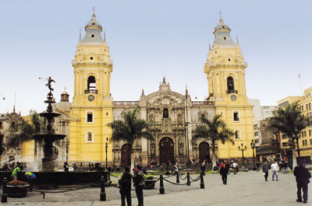

Lima City Tour and Larco Museum  Tour of Modern and Colonial Lima including the world famous Larco Museum - This half-day tour visits both the colonial and modern sections of Lima. Colonial sites include the lovely Plaza Mayor, the Government Palace, San Francisco Church and the exquisite Torre Tagle Palace modern day seat of the Ministry of Foreign Affairs. In modern Lima, drive along the exclusive residential areas of Miraflores and San Isidro. | 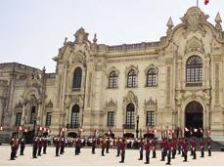

Continue to the Larco Museum, founded in 1926, it displays remarkable chronological galleries providing an excellent overview on 3000 years of development of Peruvian pre-Columbian history. Located in a unique vice-royal mansion of the 18th century built over a 7th century pre-Columbian pyramid is surrounded by beautiful gardens. The Larco Museum also features the finest gold and silver collection from Ancient Peru and the famous erotic archaeological collection, one of the most visited Peruvian tourist attractions. | 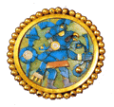

Day 2 – Wednesday – Lima – Chiclayo - Lord of Sipan Archaeological Site (B)  Transfer to the airport for your flight to Chiclayo. Upon arrival at the airport a host will meet and assist you in transferring to the hotel and help you in registering. Visit the complex of Huaca Rajada, which comprises two huge pyramids made of adobe mud in front of which there is a platform wit two royal mausoleum. The intact remains of this important Mochica ruler were discovered here in 1987. Visit the Lord of Sipan archaeological site. In the fourth century AD, the Moche people buried one of their greatest warlords. He was buried with his head pointing south, his nose and ears covered with gold relics and his feet clad in silver. Also known as The Lord of Sipan, he was accompanied by his sacrificed subjects; women, children and llamas, similar to the way the finest warriors of the era accompanied their overlord on his voyage to the Afterlife. | 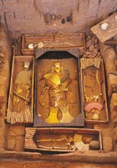

Day 3 – Thursday – Chiclayo - Trujillo - City Tour (B)  Transfer in bus to Trujillo. Upon arrival a host will meet and assist you in transferring to the hotel and help you in registering. Then tour the city of Trujillo, known as “City of the Eternal Spring". Tour includes the Main Square, the Cathedral and the beautiful residential and commercial areas with magnificent colonial houses and well preserved porches, balconies and churches such as the Colonial Mansions of "Casa Iturregui" and "Casa Bracamonte". Visit the National University of Trujillo Museum where you will find cultural expressions of Peru´s diverse Pre-Hispanic periods. | 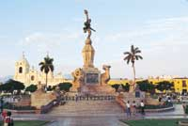

Day 4 – Friday – Trujillo - Chan Chan Archeological Site - Lima (B)  Visit Chan Chan, the former capital of Chimu Empire. This Empire reached its apogee in the 15th century, not long before falling to the Incas . The planning of this huge city, the largest in pre-Columbian America, reflects a strict political and social strategy, marked by the city's division into nine 'citadels' or 'palaces' forming autonomous units. This pre-Columbian adobe city is famous for its archaeological site in South America!. From Chan Chan you will visit the seashore village of Huanchaco, known for its totora seahorses - a typical small reed boat used for fishing. Then visit one of the most important centers of the ancient Moche. This pre-Inca civilization, a warrior culture, once dominated the valleys of the northern coast of Peru. | 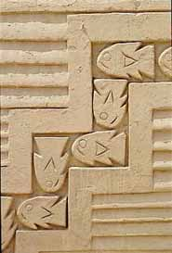

The Temple of the Moon is a beautifully decorated temple representing the spiritual center of the Moche culture. The monument consists of a series of temples built one above the other along several years. At the top of the ramps of mud can be seen the remains of massive walls decorated with colorful figures of deities, the most important god man Ai-Aipek feline content within sophisticated geometric designs of vibrant colors, yellow, red, ocher, black and white. Transfer to the airport for your flight to Lima. Upon arrival at the airport a host will meet and assist you in transferring to the hotel and help you in registering. | 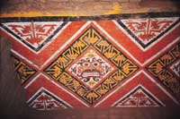

Day 5 – Saturday - Flight to Iquitos, on the Amazon River (B,L,D)  Transfer to the airport for your flight to Iquitos on the shores of the legendary Amazon River. This region is covered by dense vegetation and by primary and secondary jungle with low hills and slightly rolling landscape, crisscrossed by the many rivers of the Amazon River basin, which is born at the confluence of the Marañon and Ucayali Rivers. | 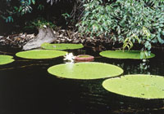

Transfer to the Explorama dock. Twenty-five mile journey down the Amazon River to Ceiba Tops where private rooms with air conditioning and hot water provide all of the comforts of home. Afternoon hike in the beautiful primary rainforest reserve surrounding Ceiba Tops which includes many huge trees festooned with epiphytes. After dinner there may be local flute or guitar music at the El Toucan Bar or the guides are always ready to relate some of the many legends of the Amazon forest.  Overnight Ceiba Tops. | 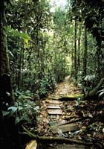

Day 6 – Sunday - Ceiba Tops (B,L,D)  Morning boat ride, spotting for dolphins, to visit a small village of Yagua Indians where your guide will explain the Yagua Indian culture and how it was affected by the arrival of Europeans and the passing of time. There will also be an opportunity to see some of the local crafts and for a demonstration of the blowgun which some of the Yagua elders still use for hunting. Afternoon walking excursion to the neighboring town of Indiana stopping along the way to see the immense Ceiba tree for which the lodge is named. Originally a Franciscan mission, Indiana has grown into a large river community with its own market, high school and small hospital. Overnight Ceiba Tops. | 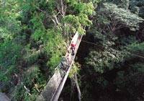

Day 7 – Monday - Ceiba Tops / Iquitos / Lima (B)  Early morning departure by boat from Ceiba Tops to Iquitos followed by transfer to the airport for your flight to Lima.  Due to the ever-changing nature of the rainforest, day-by-day activities may vary due to local conditions. | 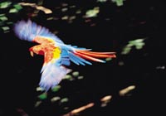

Day 8 – Tuesday - Lima – Cusco (B)  Early morning transfer from the hotel to the airport for a short but spectacular flight over the snowcapped Andes to the oldest inhabited city in the hemisphere, Cusco, at an elevation of 11,440 feet.  Upon arrival a host will meet and assist you in transferring to the hotel and in registering. | 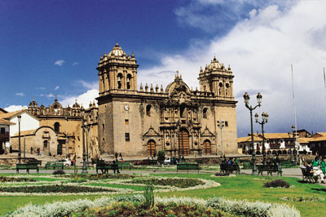

Tour of Cusco and Nearby Ruins – Visitors are caught up in the excitement of touring the ancient capital of the Inca Empire, a delightful combination of Inca and colonial architecture. The tour visits important landmarks such us Cusco's Cathedral, Plaza de Armas and Koricancha “The Temple of the Sun”. This tour of the oldest continuously inhabited city in the western hemisphere also includes the nearby ruins of Kenko, Puca-Pucara, Tambomachay as well as the Sacsayhuaman fortress, an imposing example of Inca military architecture. | 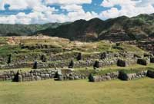

Day 9 – Wednesday - Machu Picchu (B,L)  Morning train ride through the sacred valley of Urubamba to the "Lost City of the Incas," Machu Picchu. Perched 8,200 feet above the valley, it was hidden by mountains and semi-tropical jungles for 400 years until discovered by Hiram Bingham of Yale University in 1911. Archaeologists believe that the Inca "Virgins of the Sun" took refuge from the Spanish Conquistadors here. Guided tour of the ruins upon arrival. Lunch is at the Orient Express’ Sanctuary Lodge located just a few steps from the Inca citadel. | 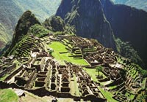

Day 10 – Thursday - Pisac Market and Ollantaytambo Archaeological Complex (B,L)  Full Day Excursion to the Pisac Indian Market and the Ollantaytambo Fortress - Morning departure for a drive through the fertile countryside of the Urubamba Valley to the colonial village of Pisac where a unique Indian Market takes place daily. The variety of products offered is overwhelming, from pottery with reproductions of archaeological pieces, to all kinds of textiles, jewelry and Peruvian handicrafts. During your visit to this bustling marketplace you will have the opportunity to bargain with the artisans and indigenous traders. Grab the items you like, you will hardly see the same one again. | 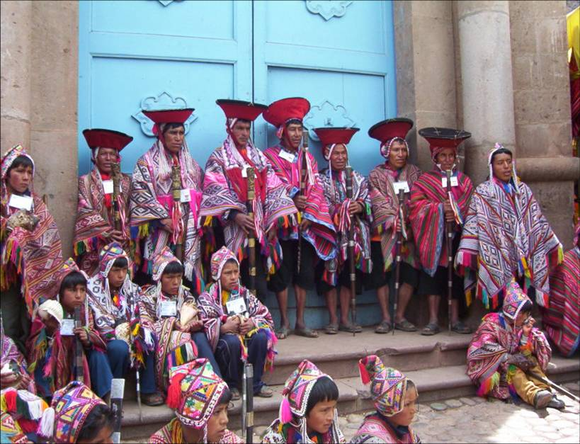

Continue to the Ollantaytambo archaeological complex, the Incas built it as a fort that included a temple, agricultural terraces, and an urban area. There are two distinct sectors: The religious and worship zone, and the residential area. Ollantaytambo was an important administrative center with probable military functions if one considers the walls and towers. There are also traces of ancient roads and aqueducts. The town of Ollantaytambo is called a "Living Inca Town" since the inhabitants maintain very old practices and customs. Lunch is at a beautiful country estate on the shores of the Urubamba River. | 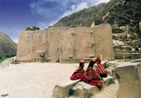

Day 11 – Friday - Cusco – Free Day (B)  Wandering through this lovely city, exploring the astonishing narrow streets of this tile roof colonial town will be your unforgettable experience. You will find something astounding at every turn. Great buys are the traditional Peruvian handicrafts, alpaca-wool sweaters and rugs, ponchos, pottery, gold and silver jewelry, leather goods, etc. Because there are such a variety of products, we strongly suggest that when you like any particular item, you should buy it - you may not find the same item in other store. Many visitors to Cusco return home wishing they had a free day to discover this imperial city on their own, a free day in Cusco is a MUST! | 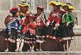

Day 12 - Saturday – Cusco – Lima – Home (B)  Transfer to the airport for your departure to Lima and your connecting international flight. Arrive home full of great memories of the rich tradition of Colonial Lima and the mystical Land of the Incas. | 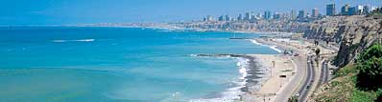

   End of Services   

Tour includes:
● All airport transfers listed in the itinerary
● Baggage handling at airports and at hotels
● All tours and excursions indicated in the itinerary
● All entrance fees and transfers needed to operate tours and excursions
● All train tickets, bus tickets and boat services needed to operate tours and excursions
● Excursion to Machu Picchu is aboard the Vistadome Train.
● Lunch in the excursion to Machu Picchu: Lunch at Sanctuary Lodge
● Service of a bilingual licensed tour guide for all tours and excursions
● All meals indicated in the itinerary. B for breakfast, L for lunch. D for dinner
● Hotel accommodation and hotel service charge
● Hotel taxes are exempt for foreigners visiting Peru
● When domestic airfare within Peru is specified as included: Airfare includes all queues, security fee, fuel surcharges and 18% Peruvian sales tax.

Not included:
● Extra expenses in case of modifying the itinerary due to flight cancelation, strikes or blocking of roads and train tracks by demonstrators or political activists. Travel insurance is strongly recommended.
● When staying overnight in Machu Picchu, the entrance fee for the 2nd day in Machu Picchu is not included. This can be added to the itinerary upon request
● Expenses such us beverages on meals, tips, laundry, phone calls and other personal expenses are not included
● When a cruise to the Galapagos Islands is part of the itinerary, the Galapagos National Park Tax is not included. It is payable upon arrival at the Galapagos Islands

Cancelation Penalties for FIT’s
● The cancellation penalty is 100% when services are cancelled within 30 days of arrival.
● When the deadline to cancel without penalties is longer than 30 days, Fiesta Tours Peru will notify you upon confirmation of services.
● Amazon river cruises and Galapagos island cruises are not refundable when services are cancelled within 90 days of arrival. When deadline changes, clients will be notified.

General Conditions for Groups
● Rooming list is due 50 days prior to arrival ⁽¹⁾.
● Payment is due 50 days prior to arrival.
● An updated number of rooms to be needed is recommended 90 days prior to arrival.
● Hotels’ cancellation penalty will be provided upon confirmation.
● Transfers and tours have a 100% cancellation penalty for services cancelled within 30 days of arrival.
● Airfares have a 100% cancellation penalty for flights cancelled within 35 days of departure.
● Inka Terra Hotels requires a 20% non-refundable deposit 95 days prior to arrival. They reserve the right to request a 20% non-refundable deposit at any given moment. Final rooming list is due 65 days prior to arrival.
⁽¹⁾ The following hotels will require the final rooming list 65 days prior to arrival: Belmond Hotels, J.W. Marriott and Gran Hotel Faraona. ^{V-Apr-15-2014}

Please review our General Conditions
http://www.fiestatoursperu.com/gcenglish/

    

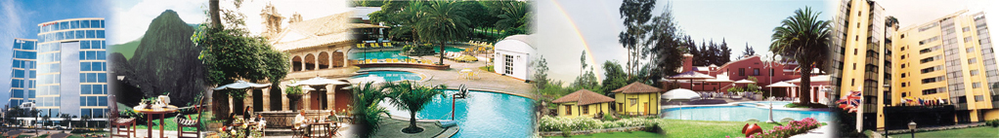
Hotels used in Tour Packages: For Discover Peru Series – 2023
City | Tourist | Tourist Superior | First Class | First Class Superior | Deluxe | Luxury
Lima | Arawi Miraflores  Express | El Tambo  Peru #2 | Arawi Miraflores  Prime | Dazzler By Wyndham  Lima Miraflores | Hyatt Centric  San Isidro | Miraflores Park,  A Belmond, Lima
Cusco | Terra Andina  Colonial Mansion | Terra Andina  Colonial Mansion | Xima Cusco Hotel | Sonesta  Hotel Cusco | Palacio del Inka  A Luxury  Collection | Monasterio,  A Belmond Hotel,  Cusco
Valle Sagrado | Ava Spot | Villa Urubamba | San Agustín  Monasterio  de la Recoleta | Sonesta Posadas  del Inka Yucay | Tambo del Inka  Luxury Collection  Resort & Spa | Río Sagrado,  A Belmond Hotel,  Sacred Valley
Aguas  Calientes | Flowers House  Machu Picchu | Casa Andina Standard  Machu Picchu | El Mapi Hotel | El Mapi Hotel | Inkaterra  Machu Picchu  Pueblo | Sanctuary Lodge,  A Belmond Hotel,  Machu Picchu
Arequipa | Casa Andina Standard  (Hab. Tradicional) | Casa Andina Standard  (Hab. Superior) | El Cabildo  Hotel | Casa Andina  Select Arequipa | Costa del Sol  Wyndham Arequipa  (Hab.Junior Suite) | CIRQA - Relais  & Châteaux  (Hab. Claustro)
Colca | Casa Andina  Standard Colca | Casa Andina Standard Colca | Aranwa Pueblito  Encantado  del Colca (Hab.Deluxe) | Aranwa Pueblito  Encantado  del Colca (Hab.Deluxe) | Aranwa Pueblito  Encantado  del Colca (Hab.Suite) | Las Casitas, A Belmond  Hotel, Colca Canyon  (Hab. Casita Garden View)
Puno | Casona Plaza  Hotel Puno | Xima Exclusive  Puno | Jose Antonio  Puno | Sonesta Posadas  del Inca Puno | Titilaka  (Hab. Explorer) | Titilaka  (Hab. Dusk/Dawn)
Trujillo | Hotel Paraiso Trujillo | Casa Andina  Standard Trujillo | El Gran Marques | Costa del Sol  Wyndham Trujillo  (Hab.Standard) | Costa del Sol  Wyndham Trujillo  (Hab.Superior) | Costa del Sol  Wyndham Trujillo  (Hab.Premium
Chiclayo | Intiotel | WinMeier Hotel | Costa del Sol  Wyndham Chiclayo | Costa del Sol  Wyndham Chiclayo | Casa Andina Select  (Hab.Junior Suite) | Casa Andina Select  (Hab.Suite)
Ica | Las Dunas o  Viñas Queirolo | Las Dunas o  Viñas Queirolo | Las Dunas o  Viñas Queirolo | Las Dunas o  Viñas Queirolo | Las Dunas o  Viñas Queirolo | Las Dunas o  Viñas Queirolo
Paracas | San Agustín  Paracas Playa | San Agustín  Paracas Playa | La Hacienda  Bahía Paracas | Doubletree by Hilton  Resort Paracas | Hotel Paracas,  A Luxury Collection  Resort (Hab.Deluxe  Garden view) | Hotel Paracas,  A Luxury Collection  Resort (Hab.Deluxe  Ocean front view)
Nazca | Casa Andina Standard Nazca | Majoro | Majoro | Hotel Nuevo Cantayoc | Hotel Nuevo Cantayoc | Hotel Nuevo Cantayoc
Iquitos - City | Victoria Regia | Victoria Regia | DoubleTree by Hilton Hotel Iquitos | DoubleTree by Hilton Hotel Iquitos | DoubleTree by Hilton Hotel Iquitos | DoubleTree by Hilton Hotel Iquitos
Iquitos -  Lodges | Ceiba Tops | Ceiba Tops | Ceiba Tops | Ceiba Tops | Ceiba Tops | Ceiba Tops
Puerto  Maldonado | Posada Amazonas | Posada Amazonas | Inkaterra Hacienda Concepcion | Inkaterra Hacienda Concepcion | Inkaterra Reserva Amazonica | Inkaterra Reserva Amazonica

TOURIST CLASS HOTELS | Discover Peru # 32  2023 Prices per person in US$ - Airfare not included
 | SIB Premium |  | Private Services
 | Min 1 | Min 2 | 1 | 2 | 3 / 4 | 5 / 9 | 10/14 | 15/19 | 20/24 | 25/29 | 30 up
Double Room |  | 2800 |  | 3316 | 2787 | 2518 | 2160 | 2098 | 2071 | 1987 | 1935
Triple Room |  | 2799 |  |  | 2786 | 2516 | 2159 | 2096 | 2070 | 1986 | 1934
Single Room | 4396 | 3151 | 5351 | 3667 | 3138 | 2868 | 2511 | 2448 | 2422 | 2338 | 2286

TOURIST SUPERIOR HOTELS | Discover Peru # 32  2023 Prices per person in US$ - Airfare not included
 | SIB Premium |  | Private Services
 | Min 1 | Min 2 | 1 | 2 | 3 / 4 | 5 / 9 | 10/14 | 15/19 | 20/24 | 25/29 | 30 up
Double Room |  | 2848 |  | 3364 | 2835 | 2566 | 2208 | 2146 | 2119 | 2035 | 1983
Triple Room |  | 2823 |  |  | 2810 | 2540 | 2183 | 2120 | 2094 | 2010 | 1958
Single Room | 4500 | 3255 | 5455 | 3771 | 3242 | 2972 | 2615 | 2552 | 2526 | 2442 | 2390

FIRST CLASS HOTELS | Discover Peru # 32  2023 Prices per person in US$ - Airfare not included
 | SIB Premium |  | Private Services
 | Min 1 | Min 2 | 1 | 2 | 3 / 4 | 5 / 9 | 10/14 | 15/19 | 20/24 | 25/29 | 30 up
Double Room |  | 2915 |  | 3431 | 2902 | 2632 | 2275 | 2212 | 2186 | 2102 | 2050
Triple Room |  | 2900 |  |  | 2887 | 2618 | 2260 | 2198 | 2171 | 2087 | 2035
Single Room | 4607 | 3362 | 5562 | 3878 | 3348 | 3079 | 2722 | 2659 | 2632 | 2548 | 2496

FIRST CLASS SUPERIOR HOTELS | Discover Peru # 32  2023 Prices per person in US$ - Airfare not included
 | SIB Premium |  | Private Services
 | Min 1 | Min 2 | 1 | 2 | 3 / 4 | 5 / 9 | 10/14 | 15/19 | 20/24 | 25/29 | 30 up
Double Room |  | 3036 |  | 3552 | 3023 | 2754 | 2396 | 2334 | 2307 | 2223 | 2171
Triple Room |  | 3019 |  |  | 3006 | 2736 | 2379 | 2316 | 2290 | 2206 | 2154
Single Room | 4864 | 3619 | 5819 | 4135 | 3606 | 3336 | 2979 | 2916 | 2890 | 2806 | 2754

DELUXE HOTELS | Discover Peru # 32  2023 Prices per person in US$ - Airfare not included
 | SIB Premium |  | Private Services
 | Min 1 | Min 2 | 1 | 2 | 3 / 4 | 5 / 9 | 10/14 | 15/19 | 20/24 | 25/29 | 30 up
Double Room |  | 3811 |  | 4327 | 3798 | 3528 | 3171 | 3108 | 3082 | 2998 | 2946
Triple Room |  | 4227 |  |  | 4214 | 3944 | 3587 | 3524 | 3498 | 3414 | 3362
Single Room | 6428 | 5183 | 7383 | 5699 | 5170 | 4900 | 4543 | 4480 | 4454 | 4370 | 4318

LUXURY HOTELS | Discover Peru # 32  2023 Prices per person in US$ - Airfare not included
 | SIB Premium |  | Private Services
 | Min 1 | Min 2 | 1 | 2 | 3 / 4 | 5 / 9 | 10/14 | 15/19 | 20/24 | 25/29 | 30 up
Double Room |  | 4282 |  | 4798 | 4268 | 3999 | 3642 | 3579 | 3552 | 3468 | 3416
Triple Room |  | 4844 |  |  | 4831 | 4562 | 4204 | 4142 | 4115 | 4031 | 3979
Single Room | 7368 | 6123 | 8323 | 6639 | 6110 | 5840 | 5483 | 5420 | 5394 | 5310 | 5258

