DISCOVER PERU # 36
10 Days / 9 Nights

Lima, Chiclayo, Trujillo, Amazon Adventure at Posada Amazonas, Cusco,
Pisac Indian Market and Ollantaytambo Fortress, Machu Picchu

Day-by-Day Itinerary

Day 1 – Thursday - Lima - Arrival  Arrival in Lima, the "City of Kings" famous for its Spanish Colonial architecture, extraordinary museums and cuisine. Lima is internationally recognized as the "Gastronomic Capital of the Americas", and its cuisine is considered among the most diverse and exquisite in the world on par with French cuisine. Upon arrival a host will meet and assist you in transferring to the hotel and in registering. | 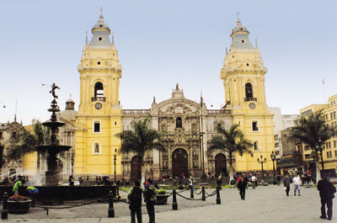

Lima City Tour and Larco Museum  Tour of Modern and Colonial Lima including the world famous Larco Museum - This half-day tour visits both the colonial and modern sections of Lima. Colonial sites include the lovely Plaza Mayor, the Government Palace, San Francisco Church and the exquisite Torre Tagle Palace modern day seat of the Ministry of Foreign Affairs. In modern Lima, drive along the exclusive residential areas of Miraflores and San Isidro. | 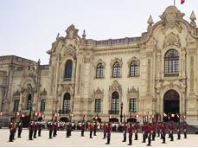

Continue to the Larco Museum, founded in 1926, it displays remarkable chronological galleries providing an excellent overview on 3000 years of development of Peruvian pre-Columbian history. Located in a unique vice-royal mansion of the 18th century built over a 7th century pre-Columbian pyramid is surrounded by beautiful gardens. The Larco Museum also features the finest gold and silver collection from Ancient Peru and the famous erotic archaeological collection, one of the most visited Peruvian tourist attractions. | 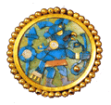

Day 2 – Friday - Lima – Chiclayo - Lord of Sipan Archaeological Site (B)  Transfer to the airport for your flight to Chiclayo. Upon arrival at the airport a host will meet and assist you in transferring to the hotel and help you in registering. Visit the complex of Huaca Rajada, which comprises two huge pyramids made of adobe mud in front of which there is a platform wit two royal mausoleum. The intact remains of this important Mochica ruler were discovered here in 1987. Visit the Lord of Sipan archaeological site. In the fourth century AD, the Moche people buried one of their greatest warlords. He was buried with his head pointing south, his nose and ears covered with gold relics and his feet clad in silver. Also known as The Lord of Sipan, he was accompanied by his sacrificed subjects; women, children and llamas, similar to the way the finest warriors of the era accompanied their overlord on his voyage to the Afterlife. | 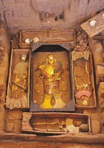
Day 3 – Saturday – Chiclayo - Trujillo City Tour (B)  Transfer in bus to Trujillo. Upon arrival a host will meet and assist you in transferring to the hotel and help you in registering. Tour the city of Trujillo, known as “City of the Eternal Spring". Tour includes the Main Square, the Cathedral and the beautiful residential and commercial areas with magnificent colonial houses and well preserved porches, balconies and churches such as the Colonial Mansions of "Casa Iturregui" and "Casa Bracamonte". Visit the National University of Trujillo Museum where you will find cultural expressions of Peru´s diverse Pre-Hispanic periods. | 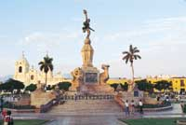

Day 4 – Sunday – Trujillo - Chan Chan Archeological Site - Lima (B,L)  Visit Chan Chan, the former capital of Chimu Empire. This Empire reached its apogee in the 15th century, not long before falling to the Incas . The planning of this huge city, the largest in pre-Columbian America, reflects a strict political and social strategy, marked by the city's division into nine 'citadels' or 'palaces' forming autonomous units. This pre-Columbian adobe city is famous for its archaeological site in South America!. From Chan Chan you will visit the seashore village of Huanchaco, known for its totora seahorses - a typical small reed boat used for fishing. Then visit one of the most important centers of the ancient Moche. This pre-Inca civilization, a warrior culture, once dominated the valleys of the northern coast of Peru. | 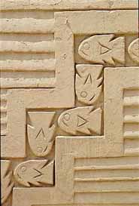

The Temple of the Moon is a beautifully decorated temple representing the spiritual center of the Moche culture. The monument consists of a series of temples built one above the other along several years. At the top of the ramps of mud can be seen the remains of massive walls decorated with colorful figures of deities, the most important god man Ai-Aipek feline content within sophisticated geometric designs of vibrant colors, yellow, red, ocher, black and white. Transfer to the airport for your flight to Lima. Upon arrival at the airport a host will meet and assist you in transferring to the hotel and help you in registering. | 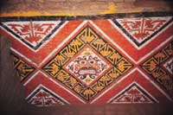

Day 5 – Monday – Flight to Puerto Maldonado, Posada Amazonas 2 Night Adventure, all meals and excursions included. (B,L,D)  Transfer to the airport for your flight to Puerto Maldonado. Upon arrival in Puerto Maldonado we will welcome you at the airport and drive you ten minutes to lodge town office. While enjoying your first taste of the forest in our gardens we will ask you to pack only the necessary gear for your next few days, and leave the rest at our safe deposit.  This helps us keep the boats and cargo light. Transfer to river pier for a forty five minute boat ride from the Tambopata Port to Posada Amazonas which will take us into the Community’s Primary Forest Private Reserve. | 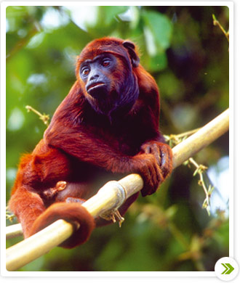

A twenty-minute walk from Posada Amazonas leads to the 30-meter scaffolding canopy tower. A banister staircase running through the middle provides safe access to the platforms above. From atop you obtain spectacular views of the vast expanses of standing forest cut by the Tambopata River winding through the middle. Now and then toucans, parrots or macaws are seen flying against the horizon, or mixed species canopy flocks land in the treetop next to you.  Evening presentation on the Inferno eco-tourism project is available every night from a staff member. | 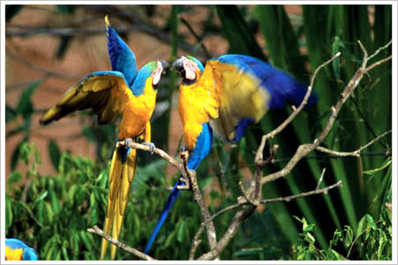

Day 6 – Tuesday – At Posada Amazonas (B,L,D)  Tres Chimbadas Oxbow Lake: Tres Chimbadas is thirty minutes by boat and forty five minutes hiking from Posada Amazonas. Once there you will paddle around the lake in a catamaran, searching for the resident family of nine giant river otters (seen by 60% of our lake visitors) and other lakeside wildlife such as caiman, hoatzin and horned screamers.  Parrot clay lick: This clay lick is only a twenty minute walk from Posada Amazonas. From a blind located about twenty meters away you will see dozens of parrots and parakeets descend on most clear mornings to ingest the clay on a river bank. Species such as Mealy and Yellow- headed Amazon, Blue-headed Parrot and Dusky headed Parakeet descend at this clay lick. The clay lick is most active at dawn and during the late mornings and mid-afternoons. | 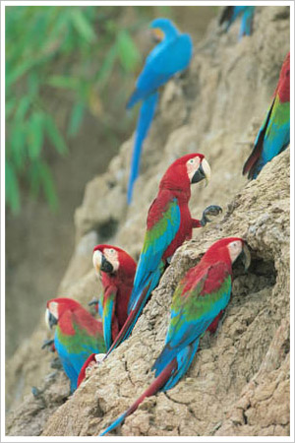

Ethno botanical Tour: A twenty minute boat drive downriver leads you to a trail designed by the staff of the Centro Ñape. The Centro Ñape is a communal organization that produces medicines out of forest plants and administers them to patients who choose their little clinic. They have produced a trail which explains the different medicinal (and other) uses of selected plants. Night walk. You will have the option of hiking out at night, when most of the mammals are active but rarely seen. Much easier to find are frogs with shapes and sounds as bizarre as their natural histories. | 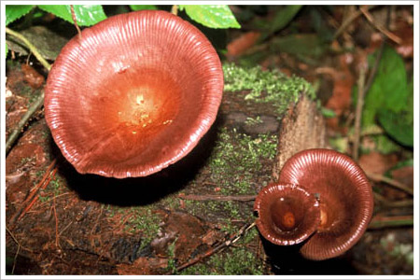

Day 7 - Wednesday – Puerto Maldonado – Cusco (B)  Retrace your river and road journey back to Puerto Maldonado and on to the airport for your departure flight to Cusco. Upon arrival at the airport a host will meet and assist you in transferring to the hotel and help you in registering. | 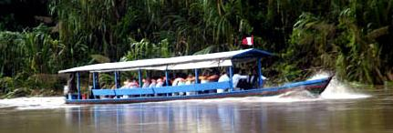

Tour of Cusco and Nearby Ruins – Visitors are caught up in the excitement of touring the ancient capital of the Inca Empire, a delightful combination of Inca and colonial architecture. The tour visits important landmarks such us Cusco's Cathedral, Plaza de Armas and Koricancha “The Temple of the Sun”. This tour of the oldest continuously inhabited city in the western hemisphere also includes the nearby ruins of Kenko, Puca-Pucara, Tambomachay as well as the Sacsayhuaman fortress, an imposing example of Inca military architecture. | 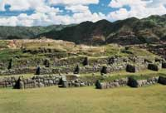

Day 8 – Thursday - Pisac Market and Ollantaytambo Archaeological Complex (B,L)  Full Day Excursion to the Pisac Indian Market and the Ollantaytambo Fortress - Morning departure for a drive through the fertile countryside of the Urubamba Valley to the colonial village of Pisac where a unique Indian Market takes place daily. The variety of products offered is overwhelming, from pottery with reproductions of archaeological pieces, to all kinds of textiles, jewelry and Peruvian handicrafts. During your visit to this bustling marketplace you will have the opportunity to bargain with the artisans and indigenous traders. Grab the items you like, you will hardly see the same one again. | 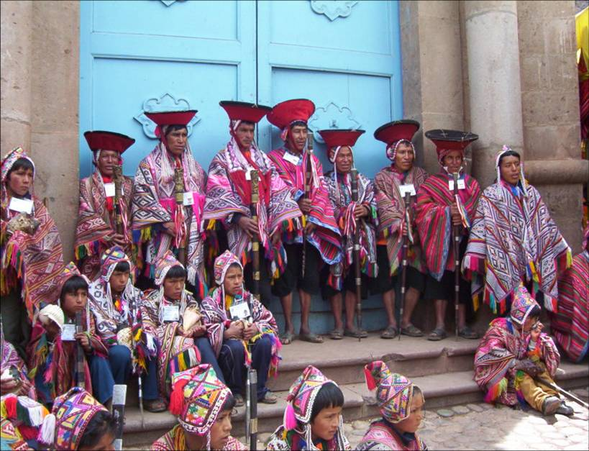

Continue to the Ollantaytambo archaeological complex, the Incas built it as a fort that included a temple, agricultural terraces, and an urban area. There are two distinct sectors: The religious and worship zone, and the residential area. Ollantaytambo was an important administrative center with probable military functions if one considers the walls and towers. There are also traces of ancient roads and aqueducts. The town of Ollantaytambo is called a "Living Inca Town" since the inhabitants maintain very old practices and customs. Lunch is at a beautiful country estate on the shores of the Urubamba River. | 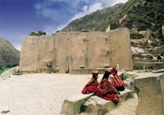

Day 9 – Friday - Machu Picchu (B,L)  Morning train ride through the sacred valley of Urubamba to the "Lost City of the Incas," Machu Picchu. Perched 8,200 feet above the valley, it was hidden by mountains and semi-tropical jungles for 400 years until discovered by Hiram Bingham of Yale University in 1911. Archaeologists believe that the Inca "Virgins of the Sun" took refuge from the Spanish Conquistadors here. Guided tour of the ruins upon arrival. Lunch is at the Orient Express’ Sanctuary Lodge located just a few steps from the Inca citadel. | 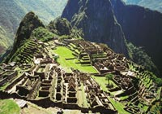

Day 10 – Saturday – Cusco – Lima – Home (B)  Transfer to the airport for your departure to Lima and your connecting international flight. Arrive home full of great memories of the rich tradition of Colonial Lima and the mystical Land of the Incas. | 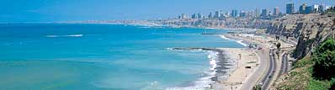

   End of Services   

Tour includes:
● All airport transfers listed in the itinerary
● Baggage handling at airports and at hotels
● All tours and excursions indicated in the itinerary
● All entrance fees and transfers needed to operate tours and excursions
● All train tickets, bus tickets and boat services needed to operate tours and excursions
● Excursion to Machu Picchu is aboard the Vistadome Train.
● Lunch in the excursion to Machu Picchu: Lunch at Sanctuary Lodge
● Service of a bilingual licensed tour guide for all tours and excursions
● All meals indicated in the itinerary. B for breakfast, L for lunch. D for dinner
● Hotel accommodation and hotel service charge
● Hotel taxes are exempt for foreigners visiting Peru
● When domestic airfare within Peru is specified as included: Airfare includes all queues, security fee, fuel surcharges and 18% Peruvian sales tax.

Not included:
● Extra expenses in case of modifying the itinerary due to flight cancelation, strikes or blocking of roads and train tracks by demonstrators or political activists. Travel insurance is strongly recommended.
● When staying overnight in Machu Picchu, the entrance fee for the 2nd day in Machu Picchu is not included. This can be added to the itinerary upon request
● Expenses such us beverages on meals, tips, laundry, phone calls and other personal expenses are not included
● When a cruise to the Galapagos Islands is part of the itinerary, the Galapagos National Park Tax is not included. It is payable upon arrival at the Galapagos Islands

Cancelation Penalties for FIT’s
● The cancellation penalty is 100% when services are cancelled within 30 days of arrival.
● When the deadline to cancel without penalties is longer than 30 days, Fiesta Tours Peru will notify you upon confirmation of services.
● Amazon river cruises and Galapagos island cruises are not refundable when services are cancelled within 90 days of arrival. When deadline changes, clients will be notified.

General Conditions for Groups
● Rooming list is due 50 days prior to arrival ⁽¹⁾.
● Payment is due 50 days prior to arrival.
● An updated number of rooms to be needed is recommended 90 days prior to arrival.
● Hotels’ cancellation penalty will be provided upon confirmation.
● Transfers and tours have a 100% cancellation penalty for services cancelled within 30 days of arrival.
● Airfares have a 100% cancellation penalty for flights cancelled within 35 days of departure.
● Inka Terra Hotels requires a 20% non-refundable deposit 95 days prior to arrival. They reserve the right to request a 20% non-refundable deposit at any given moment. Final rooming list is due 65 days prior to arrival.
⁽¹⁾ The following hotels will require the final rooming list 65 days prior to arrival: Belmond Hotels, J.W. Marriott and Gran Hotel Faraona. ^{V-Apr-15-2014}

Please review our General Conditions
http://www.fiestatoursperu.com/gcenglish/

    
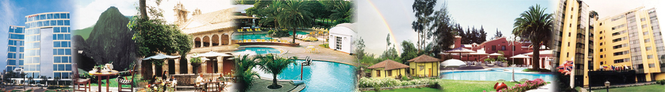
Hotels used in Tour Packages: For Discover Peru Series – 2023
City | Tourist | Tourist Superior | First Class | First Class Superior | Deluxe | Luxury
Lima | Arawi Miraflores  Express | El Tambo  Peru #2 | Arawi Miraflores  Prime | Dazzler By Wyndham  Lima Miraflores | Hyatt Centric  San Isidro | Miraflores Park,  A Belmond, Lima
Cusco | Terra Andina  Colonial Mansion | Terra Andina  Colonial Mansion | Xima Cusco Hotel | Sonesta  Hotel Cusco | Palacio del Inka  A Luxury  Collection | Monasterio,  A Belmond Hotel,  Cusco
Valle Sagrado | Ava Spot | Villa Urubamba | San Agustín  Monasterio  de la Recoleta | Sonesta Posadas  del Inka Yucay | Tambo del Inka  Luxury Collection  Resort & Spa | Río Sagrado,  A Belmond Hotel,  Sacred Valley
Aguas  Calientes | Flowers House  Machu Picchu | Casa Andina Standard  Machu Picchu | El Mapi Hotel | El Mapi Hotel | Inkaterra  Machu Picchu  Pueblo | Sanctuary Lodge,  A Belmond Hotel,  Machu Picchu
Arequipa | Casa Andina Standard  (Hab. Tradicional) | Casa Andina Standard  (Hab. Superior) | El Cabildo  Hotel | Casa Andina  Select Arequipa | Costa del Sol  Wyndham Arequipa  (Hab.Junior Suite) | CIRQA - Relais  & Châteaux  (Hab. Claustro)
Colca | Casa Andina  Standard Colca | Casa Andina Standard Colca | Aranwa Pueblito  Encantado  del Colca (Hab.Deluxe) | Aranwa Pueblito  Encantado  del Colca (Hab.Deluxe) | Aranwa Pueblito  Encantado  del Colca (Hab.Suite) | Las Casitas, A Belmond  Hotel, Colca Canyon  (Hab. Casita Garden View)
Puno | Casona Plaza  Hotel Puno | Xima Exclusive  Puno | Jose Antonio  Puno | Sonesta Posadas  del Inca Puno | Titilaka  (Hab. Explorer) | Titilaka  (Hab. Dusk/Dawn)
Trujillo | Hotel Paraiso Trujillo | Casa Andina  Standard Trujillo | El Gran Marques | Costa del Sol  Wyndham Trujillo  (Hab.Standard) | Costa del Sol  Wyndham Trujillo  (Hab.Superior) | Costa del Sol  Wyndham Trujillo  (Hab.Premium
Chiclayo | Intiotel | WinMeier Hotel | Costa del Sol  Wyndham Chiclayo | Costa del Sol  Wyndham Chiclayo | Casa Andina Select  (Hab.Junior Suite) | Casa Andina Select  (Hab.Suite)
Ica | Las Dunas o  Viñas Queirolo | Las Dunas o  Viñas Queirolo | Las Dunas o  Viñas Queirolo | Las Dunas o  Viñas Queirolo | Las Dunas o  Viñas Queirolo | Las Dunas o  Viñas Queirolo
Paracas | San Agustín  Paracas Playa | San Agustín  Paracas Playa | La Hacienda  Bahía Paracas | Doubletree by Hilton  Resort Paracas | Hotel Paracas,  A Luxury Collection  Resort (Hab.Deluxe  Garden view) | Hotel Paracas,  A Luxury Collection  Resort (Hab.Deluxe  Ocean front view)
Nazca | Casa Andina Standard Nazca | Majoro | Majoro | Hotel Nuevo Cantayoc | Hotel Nuevo Cantayoc | Hotel Nuevo Cantayoc
Iquitos - City | Victoria Regia | Victoria Regia | DoubleTree by Hilton Hotel Iquitos | DoubleTree by Hilton Hotel Iquitos | DoubleTree by Hilton Hotel Iquitos | DoubleTree by Hilton Hotel Iquitos
Iquitos -  Lodges | Ceiba Tops | Ceiba Tops | Ceiba Tops | Ceiba Tops | Ceiba Tops | Ceiba Tops
Puerto  Maldonado | Posada Amazonas | Posada Amazonas | Inkaterra Hacienda Concepcion | Inkaterra Hacienda Concepcion | Inkaterra Reserva Amazonica | Inkaterra Reserva Amazonica

TOURIST CLASS HOTELS | Discover Peru # 36  2023 Prices per person in US$ - Airfare not included
 | SIB Premium |  | Private Services
 | Min 1 | Min 2 | 1 | 2 | 3 / 4 | 5 / 9 | 10/14 | 15/19 | 20/24 | 25/29 | 30 up
Double Room |  | 2596 |  | 3102 | 2618 | 2403 | 2122 | 2087 | 2063 | 1982 | 1935
Triple Room |  | 2595 |  |  | 2616 | 2402 | 2120 | 2086 | 2062 | 1980 | 1934
Single Room | 4294 | 3024 | 5227 | 3530 | 3046 | 2831 | 2550 | 2515 | 2491 | 2410 | 2363

TOURIST SUPERIOR HOTELS | Discover Peru # 36  2023 Prices per person in US$ - Airfare not included
 | SIB Premium |  | Private Services
 | Min 1 | Min 2 | 1 | 2 | 3 / 4 | 5 / 9 | 10/14 | 15/19 | 20/24 | 25/29 | 30 up
Double Room |  | 2635 |  | 3140 | 2656 | 2442 | 2160 | 2126 | 2102 | 2020 | 1974
Triple Room |  | 2616 |  |  | 2638 | 2423 | 2142 | 2107 | 2083 | 2002 | 1955
Single Room | 4379 | 3110 | 5312 | 3615 | 3131 | 2916 | 2635 | 2600 | 2576 | 2495 | 2448

FIRST CLASS HOTELS | Discover Peru # 36  2023 Prices per person in US$ - Airfare not included
 | SIB Premium |  | Private Services
 | Min 1 | Min 2 | 1 | 2 | 3 / 4 | 5 / 9 | 10/14 | 15/19 | 20/24 | 25/29 | 30 up
Double Room |  | 2362 |  | 2867 | 2383 | 2168 | 1887 | 1852 | 1828 | 1747 | 1700
Triple Room |  | 2347 |  |  | 2368 | 2154 | 1872 | 1838 | 1814 | 1732 | 1686
Single Room | 3832 | 2715 | 4766 | 3220 | 2736 | 2522 | 2240 | 2206 | 2182 | 2100 | 2054

FIRST CLASS SUPERIOR HOTELS | Discover Peru # 36  2023 Prices per person in US$ - Airfare not included
 | SIB Premium |  | Private Services
 | Min 1 | Min 2 | 1 | 2 | 3 / 4 | 5 / 9 | 10/14 | 15/19 | 20/24 | 25/29 | 30 up
Double Room |  | 2447 |  | 2952 | 2468 | 2254 | 1972 | 1938 | 1914 | 1832 | 1786
Triple Room |  | 2435 |  |  | 2456 | 2242 | 1960 | 1926 | 1902 | 1820 | 1774
Single Room | 4016 | 2899 | 4950 | 3404 | 2920 | 2706 | 2424 | 2390 | 2366 | 2284 | 2238

DELUXE HOTELS | Discover Peru # 36  2023 Prices per person in US$ - Airfare not included
 | SIB Premium |  | Private Services
 | Min 1 | Min 2 | 1 | 2 | 3 / 4 | 5 / 9 | 10/14 | 15/19 | 20/24 | 25/29 | 30 up
Double Room |  | 3195 |  | 3700 | 3216 | 3002 | 2720 | 2686 | 2662 | 2580 | 2534
Triple Room |  | 3500 |  |  | 3522 | 3307 | 3026 | 2991 | 2967 | 2886 | 2839
Single Room | 5499 | 4306 | 6432 | 4811 | 4327 | 4112 | 3831 | 3796 | 3772 | 3691 | 3644

LUXURY HOTELS | Discover Peru # 36  2023 Prices per person in US$ - Airfare not included
 | SIB Premium |  | Private Services
 | Min 1 | Min 2 | 1 | 2 | 3 / 4 | 5 / 9 | 10/14 | 15/19 | 20/24 | 25/29 | 30 up
Double Room |  | 3520 |  | 4026 | 3542 | 3327 | 3046 | 3011 | 2987 | 2906 | 2859
Triple Room |  | 3923 |  |  | 3944 | 3730 | 3448 | 3414 | 3390 | 3308 | 3262
Single Room | 6148 | 4955 | 7082 | 5460 | 4976 | 4762 | 4480 | 4446 | 4422 | 4340 | 4294

