EXPLORING PERU # 4E
12 Days / 11 Nights

Lima, Amazon Adventure at Puerto Maldonado, Cusco, Sacred Valley,
Machu Picchu

Day-by-Day Itinerary

Day 1 - Lima - Arrival  Arrival in Lima, the "City of Kings" famous for its Spanish Colonial architecture, extraordinary museums and cuisine. Lima is internationally recognized as the "Gastronomic Capital of the Americas", and its cuisine is considered among the most diverse and exquisite in the world on par with French cuisine. Upon arrival a host will meet and assist you in transferring to the hotel and in registering. | 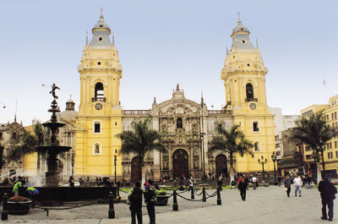

Day 2 - Lima City Tour and Larco Museum (B)  Tour of Modern and Colonial Lima including the world famous Larco Museum - This half-day tour visits both the colonial and modern sections of Lima. Colonial sites include the lovely Plaza Mayor, the Government Palace, San Francisco Church and the exquisite Torre Tagle Palace modern day seat of the Ministry of Foreign Affairs. In modern Lima, drive along the exclusive residential areas of Miraflores and San Isidro. | 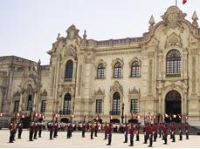

Continue to the Larco Museum, founded in 1926, it displays remarkable chronological galleries providing an excellent overview on 3000 years of development of Peruvian pre-Columbian history. Located in a unique vice-royal mansion of the 18th century built over a 7th century pre-Columbian pyramid is surrounded by beautiful gardens. The Larco Museum also features the finest gold and silver collection from Ancient Peru and the famous erotic archaeological collection, one of the most visited Peruvian tourist attractions. | 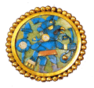

Day 3 – Flight to Puerto Maldonado, Tambopata Research Center 3 Night Adventure, all meals and excursions included. (B,L,D)  1st Day in the rainforest. Upon arrival from Lima or Cusco, we will welcome you at the airport and drive you ten minutes to our Puerto Maldonado headquarters. While enjoying your first taste of the forest in our gardens we will ask you to pack only the necessary gear for your next few days, and leave the rest at our safe deposit. This helps us keep the boats and cargo light. Transfer to Tambopata River Port, | 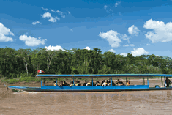

Transfer by boat to Refugio Amazonas. The two and a half hour boat ride from the Tambopata Port to Refugio Amazonas will take us past the Community of Infierno and the Tambopata National Reserve´s checkpoint and into the buffer zone of this 1.3 million hectare conservation unit. Upon arrival, the lodge manager will welcome you and brief you with important navigation and security tips. Caiman Search - We will be out at the river’s edge at night, scanning the shores with headlamps and flashlights to catch the red gleams of reflection from caiman eyes. Overnight at Refugio Amazonas. | 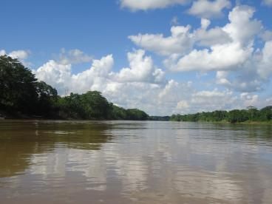

Day 4 – Refugio Amazonas / Tambopata Research Center  2nd Day in the rainforest. Canopy Tower - A thirty minute walk from Refugio Amazonas leads to the 25 meter scaffolding canopy tower. A banister staircase running through the middle provides safe access to the platforms above. From here views of mixed species canopy flocks as well as toucans, macaws and raptors are likely. Boat transfer to TRC. Stop at Chuncho Clay Lick where will have the chance to see dozens of large macaws feeding on the special sodium rich clays of the riverbank. The Chuncho clay lick probably attracts more large macaws than any other clay lick in the world and the sight of macaws taking off is truly unforgettable. | 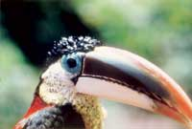

Tambopata Research Center. Overlook Trail - A three to five kilometer hike will lead us to overlooks commanding magnificent views of the Tambopata winding its way into the lowlands. The forest on this trail, regenerating on old bamboo forest, is good for Howler Monkey and Dusky Titi Monkey. Macaw Project Lectures - After dinner scientists will provide an in depth look at the biology of macaws, their feeding habits, the theories for clay lick use, their breeding and feeding ecology, population fluctuations and the threats to their conservation. Overnight at Tambopata Research Center | 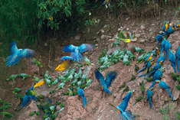

Day 5 – Tambopata Research Center (B,L,D)  3rd Day in the rainforest. Macaw Clay Lick - On most clear mornings of the year dozens of large macaws and hundreds of parrots congregate on this large river bank in a raucous and colorful spectacle which inspired a National Geographic cover story. Discretely located fifty meters from the cliff, we will observe Green-winged, Scarlet and Blue-and-gold Macaws and several species of smaller parrots descend to ingest clay. Outings are at dawn when the lick is most active. Floodplain Trail - The trail covers the prototypical rain forest with immense trees criss-crossed by creeks and ponds. We will look for Squirrel, Brown Capuchin, and Spider Monkeys as well as peccaries. | 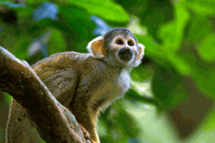

Pond Platform - Ten minutes upriver from the lodge is a tiny pond with a platform in the middle. It is a great place to spot waterfowl such as Muscovy duck, sunbittern and hoatzin along with the woodpeckers, oropendolas, flycatchers and parakeets that call this pond their home.  Night Walk - You will have the option of hiking out at night, when most of the mammals are active but rarely seen. Much easier to find are frogs with shapes and sounds as bizarre as their natural histories. Overnight at Tambopata Research Center. | 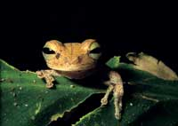
Day 6 – Tambopata Research Center / Puerto Maldonado/ Cusco – Sacred Valley (B)  We say farewell to the rainforest. We retrace our river and road journey back to Puerto Maldonado to the and on to the airport for your departure flight to Cusco. Upon arrival a host will meet and assist you for immediate transfer to the Sacred Valley at 8,200 feet of altitude. | 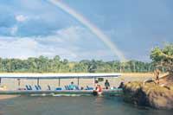

Visit to Awana Kancha, the living Museum of the Andes  This Living Museum of the Andes showcase the South American Camelids such as llamas, vicuñas, guanacos and alpacas in their native environment. You will also enjoy a spinning and weaving demonstration of ancient techniques on how to make clothing from the wool fibers of these animals. You can also see native flowers and some agricultural terraces from the Inca times. | 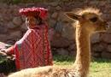

Day 7 - Pisac Market and Ollantaytambo Archaeological Complex (B,L)  Full Day Excursion to the Pisac Indian Market and the Ollantaytambo Fortress - Morning departure for a drive through the fertile countryside of the Urubamba Valley to the colonial village of Pisac where a unique Indian Market takes place daily. The variety of products offered is overwhelming, from pottery with reproductions of archaeological pieces, to all kinds of textiles, jewelry and Peruvian handicrafts. During your visit to this bustling marketplace you will have the opportunity to bargain with the artisans and indigenous traders. Grab the items you like, you will hardly see the same one again. | 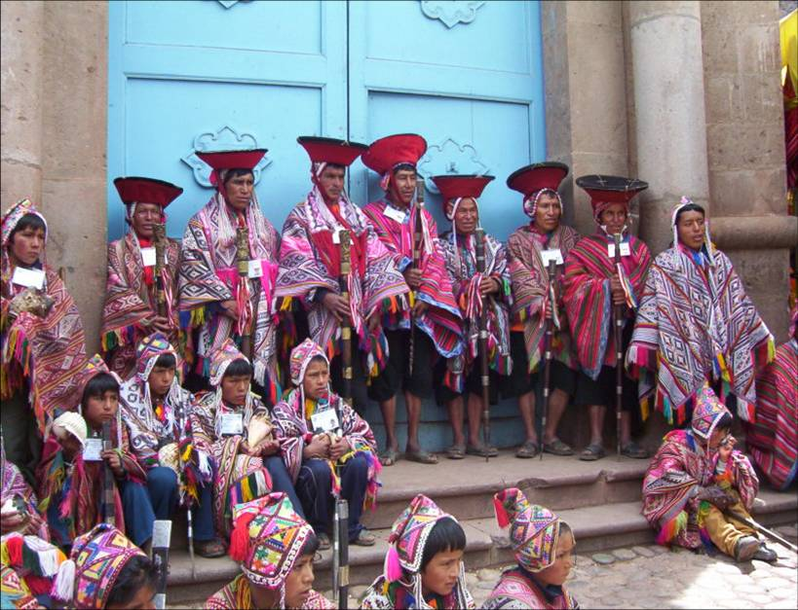

Continue to the Ollantaytambo archaeological complex, the Incas built it as a fort that included a temple, agricultural terraces, and an urban area. There are two distinct sectors: The religious and worship zone, and the residential area. Ollantaytambo was an important administrative center with probable military functions if one considers the walls and towers. There are also traces of ancient roads and aqueducts. The town of Ollantaytambo is called a "Living Inca Town" since the inhabitants maintain very old practices and customs. Lunch is at a beautiful country estate on the shores of the Urubamba River. | 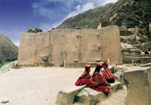

Day 8 - Moray, Maras and Quechuas (B,L)  Moray, Maras Salt Pools and Authentic Quechua Village – Pass through unspoiled and picturesque Andean communities on your way to the Incan agricultural experimental center of Moray, famous for its sunken amphitheater, made up of four circular terraces, which appear to fade away into the earth like an artificial crater. The site was apparently an Inca agricultural research station filled with fertile earth and watered by complex irrigation systems, designed for experimenting with crops at various altitudes (some of which run down to depths of 100 meters). | 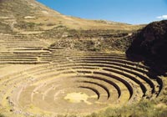

Continue to the impressive Maras salt pools formed by water emerging from a lake inside a mountain in the Urubamba Valley. An amazing view of evaporating ponds for the extraction of salt. Learn about ancestral techniques, which are still used, in agricultural, irrigation and salt-recollection tasks, as well as in Andean festivals and rites.  After lunch, visit an authentic Quechua Village to feel the way of life of the Inca's ancestors. The Inca himself was a noble Quechua. They live off the land and are always wearing their colorful ponchos, see Quechua children scamper about while woman are weaving their family's clothes. A meaningful experience! Lunch is included. | 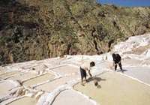

Day 9 – Sacred Valley / Machu Picchu with overnight stay (B,L)  Morning train ride through the sacred valley of Urubamba to the "Lost City of the Incas," Machu Picchu. Perched 8,200 feet above the valley, it was hidden by mountains and semi-tropical jungles for 400 years until discovered by Hiram Bingham of Yale University in 1911. Archaeologists believe that the Inca "Virgins of the Sun" took refuge from the Spanish Conquistadors here. Guided tour of the ruins upon arrival. Lunch is at the Belmond’s Sanctuary Lodge located just a few steps from the Inca citadel. Overnight stay in Aguas Calientes. | 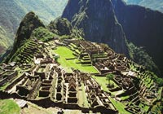

Day 10 - Machu Picchu Free Day / Return train ride (B)  Free morning to enjoy one of the most incredible sights on earth, the sanctuary of Machu Picchu. Take as much time as you need to study these magnificent ruins or hike the steep stone-paved trail of Huayna Picchu, the pyramid-shape mountain above Machu Picchu for a breathtaking “condor view” of the citadel (reservation and extra fee are needed). Or stroll to the Inca Bridge a secret entrance used by the Inca's army or walk toward the Inca Trail to find the historic Intipunku or “Sun Gate” or visit Manuel Chavez Museum or hike in Mandor Valley or just enjoy the thermal springs of the town. Afternoon return train ride. | 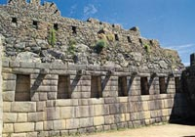

Day 11 Cusco – Free morning and afternoon city tour (B)  Wandering through this lovely city, exploring the astonishing narrow streets of this tile roof colonial town will be your unforgettable experience. You will find something astounding at every turn. Great buys are the traditional Peruvian handicrafts, alpaca-wool sweaters and rugs, ponchos, pottery, gold and silver jewelry, leather goods, etc. Because there are such a variety of products, we strongly suggest that when you like any particular item, you should buy it - you may not find the same item in other store. Many visitors to Cusco return home wishing they had some free time in Cusco to discover this imperial city on their own, a free morning in Cusco is a MUST! | 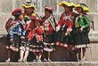

Tour of Cusco and Nearby Ruins – Visitors are caught up in the excitement of touring the ancient capital of the Inca Empire, a delightful combination of Inca and colonial architecture. The tour visits important landmarks such us Cusco's Cathedral, Santo Domingo Church, Plaza de Armas and Koricancha “The Temple of the Sun”. This tour of the oldest continuously inhabited city in the western hemisphere also includes the nearby ruins of Kenko, Puca-Pucara, Tambomachay as well as the Sacsayhuaman fortress, an imposing example of Inca military architecture. | 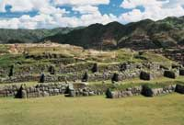

Day 12 - Cusco – Lima – Home (B)  Transfer to the airport for your departure to Lima and your connecting international flight. Arrive home full of great memories of the rich tradition of Colonial Lima and the mystical Land of the Incas. | 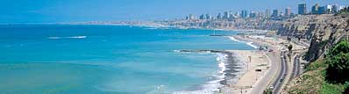

   End of Services   

Tour includes:
● All airport transfers listed in the itinerary
● Baggage handling at airports and at hotels
● All tours and excursions indicated in the itinerary
● All entrance fees and transfers needed to operate tours and excursions
● All train tickets, bus tickets and boat services needed to operate tours and excursions
● Excursion to Machu Picchu is aboard the Vistadome Train.
● Lunch in the excursion to Machu Picchu: Lunch at Sanctuary Lodge
● Service of a bilingual licensed tour guide for all tours and excursions
● All meals indicated in the itinerary. B for breakfast, L for lunch. D for dinner
● Hotel accommodation and hotel service charge
● Hotel taxes are exempt for foreigners visiting Peru
● When domestic airfare within Peru is specified as included: Airfare includes all queues, security fee, fuel surcharges and 18% Peruvian sales tax.

Not included:
● Extra expenses in case of modifying the itinerary due to flight cancelation, strikes or blocking of roads and train tracks by demonstrators or political activists. Travel insurance is strongly recommended.
● When staying overnight in Machu Picchu, the entrance fee for the 2nd day in Machu Picchu is not included. This can be added to the itinerary upon request
● Expenses such us beverages on meals, tips, laundry, phone calls and other personal expenses are not included
● When a cruise to the Galapagos Islands is part of the itinerary, the Galapagos National Park Tax is not included. It is payable upon arrival at the Galapagos Islands

Cancelation Penalties for FIT’s
● The cancellation penalty is 100% when services are cancelled within 30 days of arrival.
● When the deadline to cancel without penalties is longer than 30 days, Fiesta Tours Peru will notify you upon confirmation of services.
● Amazon river cruises and Galapagos island cruises are not refundable when services are cancelled within 90 days of arrival. When deadline changes, clients will be notified.

General Conditions for Groups
● Rooming list is due 50 days prior to arrival ⁽¹⁾.
● Payment is due 50 days prior to arrival.
● An updated number of rooms to be needed is recommended 90 days prior to arrival.
● Hotels’ cancellation penalty will be provided upon confirmation.
● Transfers and tours have a 100% cancellation penalty for services cancelled within 30 days of arrival.
● Airfares have a 100% cancellation penalty for flights cancelled within 35 days of departure.
● Inka Terra Hotels requires a 20% non-refundable deposit 95 days prior to arrival. They reserve the right to request a 20% non-refundable deposit at any given moment. Final rooming list is due 65 days prior to arrival.
⁽¹⁾ The following hotels will require the final rooming list 65 days prior to arrival: Belmond Hotels, J.W. Marriott and Gran Hotel Faraona. ^{V-Apr-15-2014}

Please review our General Conditions
http://www.fiestatoursperu.com/gcenglish/

    

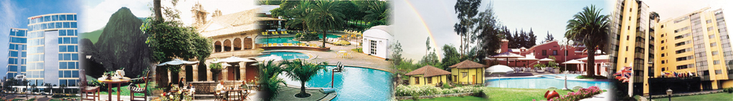
Hotels used in Tour Packages: For Exploring Peru Series – 2019
City | Tourist | Tourist Superior | First Class | First Class Superior | Deluxe | Luxury
Lima | Tambo # 1 or  Los Girasoles | Casa Andina Classic Miraflores Centro or Tambo # 2 | Casa Andina Select Miraflores or  Jose Antonio | Melia Lima or Dazzler or Four Points by Sheraton | Casa Andina Premium Miraflores or El Pardo Doubletree by Hilton Hotel | Belmond Miraflores Park or Country Club Lima
Cusco | Samay or San Agustin Internacional | Terra Andina Standard Room or Xima or Jose Antonio or Casa Andina Classic Cusco | Terra Andina Sup Room or Sonesta Hotel Cusco | Casa Andina Premium or Novotel or Costa del Sol | Palacio del Inka A Luxury Collection | Belmond Monasterio
Valle Sagrado | La Hacienda Valle or Agustos Urubamba | Villa Urubamba or San Agustin Monasterio de la Recoleta | Sonesta Posadas del Inca Yucay | Casa Andina Premium Valle Sagrado | Sol y Luna Casita(superior) or Aranwa Sacred Valley Hotel & Wellness | Belmond Rio Sagrado or Tambo del Inka A Luxury Collection
Aguas  Calientes | Hatun Samay Machu Picchu | El Mapi or Casa Andina Classic Machu Picchu | El Mapi or Casa Andina Classic Machu Picchu | Casa del Sol Machu Picchu Boutique Hotel | Inkaterra Machu Picchu Pueblo or Sumaq | Belmond Sanctuary Lodge
Arequipa | Casa Andina Classic Arequipa | Tierra Viva Arequipa Plaza | El Cabildo | Casa Andina Select Arequipa | Casa Andina Premium Arequipa | Libertador Arequipa
Colca | Casa Andina Classic Colca | Casa Andina Classic Colca | Colca Lodge or Aranwa Pueblito Encantado | Colca Lodge or Aranwa Pueblito Encantado | Colca Lodge or Aranwa Pueblito Encantado | Casitas del Colca
Puno | La Hacienda Plaza de Armas | Xima Puno | Sonesta Posadas del Inca Puno | Sonesta Posadas del Inca Puno | Casa Andina Premium Puno | Libertador Lago Titicaca
Trujillo | Posada del Rey | Costa del Sol Trujillo | Costa del Sol Trujillo | Libertador Trujillo | Libertador Trujillo | Casa Andina Premium Trujillo
Chiclayo | Wyndham Costa del Sol Chiclayo | Wyndham Costa del Sol Chiclayo | Winmeier Chiclayo | Winmeier Chiclayo | Casa Andina Select Chiclayo | Casa Andina Select Chiclayo
Ica | Las Dunas | Las Dunas | Las Dunas | Las Dunas | Las Dunas | Las Dunas
Paracas | San Agustin Paracas | San Agustin Paracas | La Hacienda Bahia Paracas | La Hacienda Bahia Paracas | DoubleTree by Hilton Resort Paracas o Aranwa Paracas Resort & Spa | Hotel Paracas A Luxury Collection Resort
Nazca | Casa Andina Classic Nazca | Majoro | Majoro | Hotel Nuevo Cantayoc | Hotel Nuevo Cantayoc | Hotel Nuevo Cantayoc
Iquitos -  Lodges | Ceiba Tops | Ceiba Tops | Ceiba Tops | Ceiba Tops | Ceiba Tops | Ceiba Tops
Iquitos - City | Victoria Regia | Victoria Regia | DoubleTree by Hilton Hotel Iquitos | DoubleTree by Hilton Hotel Iquitos | DoubleTree by Hilton Hotel Iquitos | DoubleTree by Hilton Hotel Iquitos
Puerto  Maldonado | Posada Amazonas | Posada Amazonas | La Hacienda Concepcion | La Hacienda Concepcion | Inkaterra Reserva Amazonica | Inkaterra Reserva Amazonica
Piura - Beaches | Mancora Beach Bungalows | Mancora Beach Bungalows | Vichayito Bungalows y Carpas by Aranwa | Vichayito Bungalows y Carpas by Aranwa | Arennas Mancora | Arennas Mancora

TOURIST CLASS HOTELS | Exploring Peru # 4E  2019 Prices per person in US$ - Airfare not included
Gross Rates | SIB Premium |  | Private Services
Per Person | Min 1 | Min 2 | 1 | 2 | 3 / 4 | 5 / 9 | 10/14 | 15/19 | 20/24 | 25/29 | 30 up
Double Room |  | 2851 |  | 3135 | 2804 | 2627 | 2446 | 2411 | 2370 | 2346 | 2340
Triple Room |  | 2792 |  |  | 2746 | 2568 | 2387 | 2352 | 2311 | 2287 | 2282
Single Room | 4363 | 3423 | 4956 | 3707 | 3376 | 3199 | 3018 | 2983 | 2942 | 2918 | 2912

TOURIST SUPERIOR HOTELS | Exploring Peru # 4E  2019 Prices per person in US$ - Airfare not included
Gross Rates | SIB Premium |  | Private Services
Per Person | Min 1 | Min 2 | 1 | 2 | 3 / 4 | 5 / 9 | 10/14 | 15/19 | 20/24 | 25/29 | 30 up
Double Room |  | 2983 |  | 3267 | 2936 | 2759 | 2578 | 2543 | 2502 | 2478 | 2472
Triple Room |  | 2923 |  |  | 2876 | 2699 | 2518 | 2483 | 2442 | 2418 | 2412
Single Room | 4674 | 3734 | 5267 | 4018 | 3687 | 3510 | 3328 | 3294 | 3252 | 3228 | 3223

FIRST CLASS HOTELS | Exploring Peru # 4E  2019 Prices per person in US$ - Airfare not included
Gross Rates | SIB Premium |  | Private Services
Per Person | Min 1 | Min 2 | 1 | 2 | 3 / 4 | 5 / 9 | 10/14 | 15/19 | 20/24 | 25/29 | 30 up
Double Room |  | 3095 |  | 3379 | 3048 | 2871 | 2690 | 2655 | 2614 | 2590 | 2584
Triple Room |  | 3051 |  |  | 3004 | 2827 | 2646 | 2611 | 2570 | 2546 | 2540
Single Room | 4902 | 3962 | 5495 | 4246 | 3915 | 3738 | 3556 | 3522 | 3480 | 3456 | 3451

FIRST CLASS SUPERIOR HOTELS | Exploring Peru # 4E  2019 Prices per person in US$ - Airfare not included
Gross Rates | SIB Premium |  | Private Services
Per Person | Min 1 | Min 2 | 1 | 2 | 3 / 4 | 5 / 9 | 10/14 | 15/19 | 20/24 | 25/29 | 30 up
Double Room |  | 3248 |  | 3532 | 3202 | 3024 | 2843 | 2808 | 2767 | 2743 | 2738
Triple Room |  | 3166 |  |  | 3119 | 2942 | 2760 | 2726 | 2684 | 2660 | 2655
Single Room | 5148 | 4208 | 5742 | 4492 | 4162 | 3984 | 3803 | 3768 | 3727 | 3703 | 3698

DELUXE HOTELS | Exploring Peru # 4E  2019 Prices per person in US$ - Airfare not included
Gross Rates | SIB Premium |  | Private Services
Per Person | Min 1 | Min 2 | 1 | 2 | 3 / 4 | 5 / 9 | 10/14 | 15/19 | 20/24 | 25/29 | 30 up
Double Room |  | 4052 |  | 4336 | 4006 | 3828 | 3647 | 3612 | 3571 | 3547 | 3542
Triple Room |  | 3862 |  |  | 3815 | 3638 | 3456 | 3422 | 3380 | 3356 | 3351
Single Room | 6676 | 5736 | 7270 | 6020 | 5690 | 5512 | 5331 | 5296 | 5255 | 5231 | 5226

LUXURY HOTELS | Exploring Peru # 4E  2019 Prices per person in US$ - Airfare not included
Gross Rates | SIB Premium |  | Private Services
Per Person | Min 1 | Min 2 | 1 | 2 | 3 / 4 | 5 / 9 | 10/14 | 15/19 | 20/24 | 25/29 | 30 up
Double Room |  | 5240 |  | 5524 | 5194 | 5016 | 4835 | 4800 | 4759 | 4735 | 4730
Triple Room |  | 5076 |  |  | 5030 | 4852 | 4671 | 4636 | 4595 | 4571 | 4566
Single Room | 9043 | 8103 | 9636 | 8387 | 8056 | 7879 | 7698 | 7663 | 7622 | 7598 | 7592

