PERUVIAN TREASURES # 19 - (Night Arrival)
13 Days / 12 Nights

Lima, Chiclayo, Trujillo, Puno, Cusco, Machu Picchu, Pisac Indian Market and
Ollantaytambo Fortress

Day-by-Day Itinerary

Day 1 - Monday - Lima - Arrival  Arrival in Lima, the "City of Kings" famous for its Spanish Colonial architecture, extraordinary museums and cuisine. Lima is internationally recognized as the "Gastronomic Capital of the Americas", and its cuisine is considered among the most diverse and exquisite in the world on par with French cuisine. Upon arrival a host will meet and assist you in transferring to the hotel and in registering. | 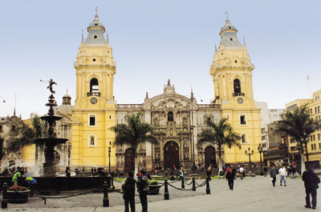

Day 2 – Tuesday - Lima City Tour and Larco Museum (B)  Tour of Modern and Colonial Lima including the world famous Larco Museum - This half-day tour visits both the colonial and modern sections of Lima. Colonial sites include the lovely Plaza Mayor, the Government Palace, San Francisco Church and the exquisite Torre Tagle Palace modern day seat of the Ministry of Foreign Affairs. In modern Lima, drive along the exclusive residential areas of Miraflores and San Isidro. | 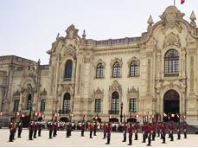

Continue to the Larco Museum, founded in 1926, it displays remarkable chronological galleries providing an excellent overview on 3000 years of development of Peruvian pre-Columbian history. Located in a unique vice-royal mansion of the 18th century built over a 7th century pre-Columbian pyramid is surrounded by beautiful gardens. The Larco Museum also features the finest gold and silver collection from Ancient Peru and the famous erotic archaeological collection, one of the most visited Peruvian tourist attractions. | 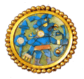

Day 3 – Wednesday - Lima – Chiclayo - Lord of Sipan Archaeological Site (B)  Transfer to the airport for your flight to Chiclayo. Upon arrival at the airport a host will meet and assist you in transferring to the hotel and help you in registering. Visit the complex of Huaca Rajada, which comprises two huge pyramids made of adobe mud in front of which there is a platform wit two royal mausoleum. The intact remains of this important Mochica ruler were discovered here in 1987. Visit the Lord of Sipan archaeological site. In the fourth century AD, the Moche people buried one of their greatest warlords. He was buried with his head pointing south, his nose and ears covered with gold relics and his feet clad in silver. Also known as The Lord of Sipan, he was accompanied by his sacrificed subjects; women, children and llamas, similar to the way the finest warriors of the era accompanied their overlord on his voyage to the Afterlife. | 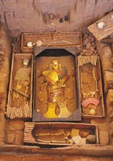

Day 4 – Thursday – Chiclayo - Trujillo City Tour (B)  Transfer in bus to Trujillo. Upon arrival a host will meet and assist you in transferring to the hotel and help you in registering. Tour the city of Trujillo, known as “City of the Eternal Spring". Tour includes the Main Square, the Cathedral and the beautiful residential and commercial areas with magnificent colonial houses and well preserved porches, balconies and churches such as the Colonial Mansions of "Casa Iturregui" and "Casa Bracamonte". Visit the National University of Trujillo Museum where you will find cultural expressions of Peru´s diverse Pre-Hispanic periods. | 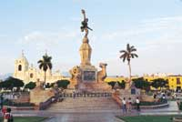

Day 5 – Friday – Trujillo - Chan Chan Archeological Site - Lima (B,L)  Visit Chan Chan, the former capital of Chimu Empire. This Empire reached its apogee in the 15th century, not long before falling to the Incas . The planning of this huge city, the largest in pre-Columbian America, reflects a strict political and social strategy, marked by the city's division into nine 'citadels' or 'palaces' forming autonomous units. This pre-Columbian adobe city is famous for its archaeological site in South America!. From Chan Chan you will visit the seashore village of Huanchaco, known for its totora seahorses - a typical small reed boat used for fishing. Then visit one of the most important centers of the ancient Moche. This pre-Inca civilization, a warrior culture, once dominated the valleys of the northern coast of Peru. | 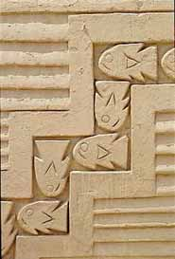

The Temple of the Moon is a beautifully decorated temple representing the spiritual center of the Moche culture. The monument consists of a series of temples built one above the other along several years. At the top of the ramps of mud can be seen the remains of massive walls decorated with colorful figures of deities, the most important god man Ai-Aipek feline content within sophisticated geometric designs of vibrant colors, yellow, red, ocher, black and white. Transfer to the airport for your flight to Lima. Upon arrival at the airport a host will meet and assist you in transferring to the hotel and help you in registering. | 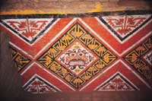

Day 6 – Saturday - Lima – Juliaca - Puno (B)  Early morning transfer from the hotel to the airport for your flight to Juliaca. Upon arrival a host will meet and assist you in transferring to the hotel and in registering. | 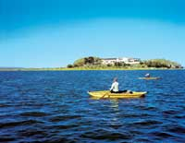

Sillustani Burial Towers  Excursion to Sillustani Burial Towers on route. This complex stands on the shore of Lake Umayo and is famous for its chullpas, large circular fortified burial towers for the chiefs and important people of the early villages of the Collao plateau. Some are 12 meters high (39 feet), and remarkable for their shape, thinner at the base and wider at the top. These ancient and impressive tombs from the pre-Inca period were built from a mixture of stone and adobe. | 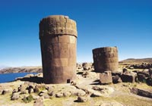

Day 7 – Sunday - Puno – Uros and Taquile Islands on Lake Titikaka (B,L)  Boat excursion to Uros and Taquile Islands on Lake Titikaka. This full day excursion will take you to the highest navigable lake in the world to the floating islands of the Uros Indians, man-made islands by tying totora reeds. The Uros considered themselves Lords of the Lake; they hunt wild birds and maintain traditional fishing methods. The men have developed an extraordinary skill in weaving reeds; producing houses, boats and handicrafts, and the women are expert knitters. | 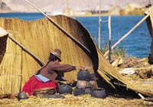

Continuing to Taquile where a native community of about 400 families still lives with the traditions and high principals of the Incas. Taquile is a very important site on Lake Titikaka for its archeological remains, the sacred and ceremonial sites, the festive activities and their rituals. Taquile is characterized by its friendly inhabitants, who maintain their customs and traditional clothing. They distinguish themselves by their detailed, fine, and colorful textiles with symmetrical decorations and symbols that reflect their way of life and Andean beliefs. Lunch is included. | 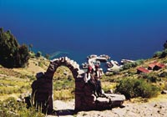

Day 8 – Monday - Puno to Cusco (B,L)  Bus journey through the Peruvian Andes from Puno to Cusco - Today one of South America's most extraordinary overland trips takes you by coach to Cusco passing through striking highland scenery and picturesque Andean villages. Brief stops at Raqchi to see the remains of the remarkable temple of Viracocha, considered by the historians an important Inca construction, and at the town of Andahuaylillas, a showcase of the colonial art in Peru, sometimes called "the Sistine Chapel of America". Lunch is included. | 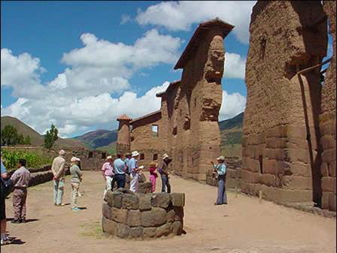

Day 9 – Tuesday - Cusco City Tour and Nearby Ruins (B)  Free morning. Tour of Cusco and Nearby Ruins – Visitors are caught up in the excitement of touring the ancient capital of the Inca Empire, a delightful combination of Inca and colonial architecture. The tour visits important landmarks such us Cusco's Cathedral, Plaza de Armas and Koricancha “The Temple of the Sun”. This tour of the oldest continuously inhabited city in the western hemisphere also includes the nearby ruins of Kenko, Puca-Pucara, Tambomachay as well as the Sacsayhuaman fortress, an imposing example of Inca military architecture. | 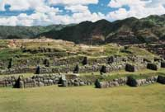

Day 10 – Wednesday - Machu Picchu (B,L)  Morning train ride through the sacred valley of Urubamba to the "Lost City of the Incas," Machu Picchu. Perched 8,200 feet above the valley, it was hidden by mountains and semi-tropical jungles for 400 years until discovered by Hiram Bingham of Yale University in 1911. Archaeologists believe that the Inca "Virgins of the Sun" took refuge from the Spanish Conquistadors here. Guided tour of the ruins upon arrival. Lunch is at the Orient Express’ Sanctuary Lodge located just a few steps from the Inca citadel. | 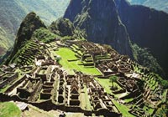

Day 11 – Thursday - Pisac Market and Ollantaytambo Archaeological Complex (B,L)  Full Day Excursion to the Pisac Indian Market and the Ollantaytambo Fortress - Morning departure for a drive through the fertile countryside of the Urubamba Valley to the colonial village of Pisac where a unique Indian Market takes place daily. The variety of products offered is overwhelming, from pottery with reproductions of archaeological pieces, to all kinds of textiles, jewelry and Peruvian handicrafts. During your visit to this bustling marketplace you will have the opportunity to bargain with the artisans and indigenous traders. Grab the items you like, you will hardly see the same one again. | 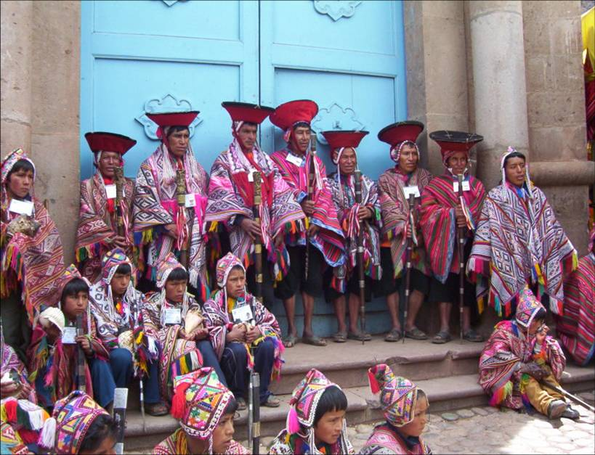

Continue to the Ollantaytambo archaeological complex, the Incas built it as a fort that included a temple, agricultural terraces, and an urban area. There are two distinct sectors: The religious and worship zone, and the residential area. Ollantaytambo was an important administrative center with probable military functions if one considers the walls and towers. There are also traces of ancient roads and aqueducts. The town of Ollantaytambo is called a "Living Inca Town" since the inhabitants maintain very old practices and customs. Lunch is at a beautiful country estate on the shores of the Urubamba River. | 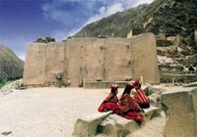

Day 12 – Friday - Cusco – Free Day (B)  Wandering through this lovely city, exploring the astonishing narrow streets of this tile roof colonial town will be your unforgettable experience. You will find something astounding at every turn. Great buys are the traditional Peruvian handicrafts, alpaca-wool sweaters and rugs, ponchos, pottery, gold and silver jewelry, leather goods, etc. Because there are such a variety of products, we strongly suggest that when you like any particular item, you should buy it - you may not find the same item in other store. Many visitors to Cusco return home wishing they had a free day to discover this imperial city on their own, a free day in Cusco is a MUST! | 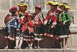

Day 13 – Saturday – Cusco – Lima – Home (B)  Transfer to the airport for your departure to Lima and your connecting international flight. Arrive home full of great memories of the rich tradition of Colonial Lima and the mystical Land of the Incas. | 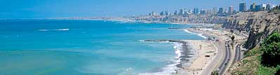

   End of Services   

Tour includes:
● All airport transfers listed in the itinerary
● Baggage handling at airports and at hotels
● All tours and excursions indicated in the itinerary
● All entrance fees and transfers needed to operate tours and excursions
● All train tickets, bus tickets and boat services needed to operate tours and excursions
● Excursion to Machu Picchu is aboard the Vistadome Train.
● Lunch in the excursion to Machu Picchu: Lunch at Sanctuary Lodge
● Service of a bilingual licensed tour guide for all tours and excursions
● All meals indicated in the itinerary. B for breakfast, L for lunch. D for dinner
● Hotel accommodation and hotel service charge
● Hotel taxes are exempt for foreigners visiting Peru
● When domestic airfare within Peru is specified as included: Airfare includes all queues, security fee, fuel surcharges and 18% Peruvian sales tax.

Not included:
● Extra expenses in case of modifying the itinerary due to flight cancelation, strikes or blocking of roads and train tracks by demonstrators or political activists. Travel insurance is strongly recommended.
● When staying overnight in Machu Picchu, the entrance fee for the 2nd day in Machu Picchu is not included. This can be added to the itinerary upon request
● Expenses such us beverages on meals, tips, laundry, phone calls and other personal expenses are not included
● When a cruise to the Galapagos Islands is part of the itinerary, the Galapagos National Park Tax is not included. It is payable upon arrival at the Galapagos Islands

Cancelation Penalties for FIT’s
● The cancellation penalty is 100% when services are cancelled within 30 days of arrival.
● When the deadline to cancel without penalties is longer than 30 days, Fiesta Tours Peru will notify you upon confirmation of services.
● Amazon river cruises and Galapagos island cruises are not refundable when services are cancelled within 90 days of arrival. When deadline changes, clients will be notified.

General Conditions for Groups
● Rooming list is due 50 days prior to arrival ⁽¹⁾.
● Payment is due 50 days prior to arrival.
● An updated number of rooms to be needed is recommended 90 days prior to arrival.
● Hotels’ cancellation penalty will be provided upon confirmation.
● Transfers and tours have a 100% cancellation penalty for services cancelled within 30 days of arrival.
● Airfares have a 100% cancellation penalty for flights cancelled within 35 days of departure.
● Inka Terra Hotels requires a 20% non-refundable deposit 95 days prior to arrival. They reserve the right to request a 20% non-refundable deposit at any given moment. Final rooming list is due 65 days prior to arrival.
⁽¹⁾ The following hotels will require the final rooming list 65 days prior to arrival: Belmond Hotels, J.W. Marriott and Gran Hotel Faraona. ^{V-Apr-15-2014}

Please review our General Conditions
http://www.fiestatoursperu.com/gcenglish/

    

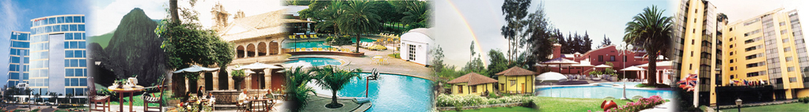
Hotels used in Tour Packages: For Peruvian Treasures Series – 2020
City | Tourist | Tourist Superior | First Class | First Class Superior | Deluxe | Luxury
Lima | Tambo # 1 or  Los Girasoles | Casa Andina Standard Miraflores Centro or Tambo # 2 | Casa Andina Select Miraflores or  Jose Antonio | Melia Lima o Dazzler or Four Points by Sheraton | Casa Andina Premium Miraflores or El Pardo Doubletree by Hilton Hotel | Belmond Miraflores Park or Country Club Lima
Cusco | Samay | Terra Andina Hotel (STD) or Xima or Jose Antonio or Casa Andina Standard Cusco | Terra Andina Hotel (Sup) or Sonesta Hotel Cusco | Casa Andina Premium or Novotel or Costa del Sol | Palacio del Inka A Luxury Collection Hotel | Belmond Monasterio
Valle Sagrado | La Hacienda Valle or Agustos Urubamba | Villa Urubamba | Sonesta Posadas del Inca Yucay | Casa Andina Premium Valle Sagrado | Sol y Luna (casita superior) or Aranwa Sacred Valley Hotel & Wellness | Tambo del Inka A Luxury Collection or Belmond Rio Sagrado
Aguas  Calientes | Hatun Samay Machu Picchu | El Mapi or Casa Andina Standard Machu Picchu | El Mapi or Casa Andina Standard Machu Picchu | Casa del Sol Machu Picchu Boutique Hotel | Inkaterra Machu Picchu Pueblo or Sumaq | Belmond Sanctuary Lodge
Arequipa | Casa Andina Standard Arequipa | Tierra Viva Arequipa Plaza | El Cabildo | Casa Andina Select Arequipa | Casa Andina Premium Arequipa | Costa del Sol Whyndham Arequipa
Colca | Casa Andina Standard Colca | Casa Andina Standard Colca | Colca Lodge or Aranwa Pueblito Encantado | Colca Lodge or Aranwa Pueblito Encantado | Colca Lodge or Aranwa Pueblito Encantado | Belmond Las Casitas
Puno | La Hacienda Plaza de Armas | Xima Puno | Sonesta Posadas del Inca Puno | Sonesta Posadas del Inca Puno | Casa Andina Private Collection Puno | GHL Hotel Lago Titicaca
Trujillo | Posada del Rey | Costa del Sol Wyndham Trujillo | Costa del Sol Wyndham Trujillo | Costa del Sol Wyndham Trujillo | Costa del Sol Wyndham Trujillo | Casa Andina Premium Trujillo
Chiclayo | Costa del Sol Wyndham Chiclayo | Costa del Sol Wyndham Chiclayo | WinMeier Hotel | WinMeier Hotel | Casa Andina Select Chiclayo | Casa Andina Select Chiclayo
Ica | Las Dunas | Las Dunas | Las Dunas | Las Dunas | Las Dunas | Las Dunas
Paracas | La Hacienda Bahia Paracas | La Hacienda Bahia Paracas | La Hacienda Bahia Paracas | La Hacienda Bahia Paracas | DoubleTree by Hilton Resort Paracas o Aranwa Paracas Resort & Spa | Hotel Paracas A Luxury Collection Resort
Nazca | Casa Andina Standard Nazca | Majoro | Majoro | Hotel Nuevo Cantayoc | Hotel Nuevo Cantayoc | Hotel Nuevo Cantayoc
Iquitos - City | Victoria Regia | Victoria Regia | DoubleTree by Hilton Hotel Iquitos | DoubleTree by Hilton Hotel Iquitos | DoubleTree by Hilton Hotel Iquitos | DoubleTree by Hilton Hotel Iquitos
Iquitos -  Lodges | Ceiba Tops | Ceiba Tops | Ceiba Tops | Ceiba Tops | Ceiba Tops | Ceiba Tops
Puerto  Maldonado | Posada Amazonas | Posada Amazonas | La Hacienda Concepcion | La Hacienda Concepcion | Inkaterra Reserva Amazonica | Inkaterra Reserva Amazonica
Piura - Beaches | Mancora Beach Bungalows | Mancora Beach Bungalows | Vichayito Bungalows y Carpas by Aranwa | Vichayito Bungalows y Carpas by Aranwa | Arennas Mancora | Arennas Mancora

TOURIST CLASS HOTELS | Peruvian Treasures # 19  2020 Prices per person in US$ - Airfare not included
Gross Rates | SIB Premium |  | Private Services
Per Person | Min 1 | Min 2 | 1 | 2 | 3 / 4 | 5 / 9 | 10/14 | 15/19 | 20/24 | 25/29 | 30 up
Double Room |  | 2439 |  | 3287 | 2704 | 2404 | 2020 | 1938 | 1887 | 1803 | 1774
Triple Room |  | 2376 |  |  | 2642 | 2342 | 1958 | 1875 | 1824 | 1740 | 1711
Single Room | 3879 | 2882 | 5654 | 3730 | 3147 | 2847 | 2463 | 2380 | 2330 | 2246 | 2216

TOURIST SUPERIOR HOTELS | Peruvian Treasures # 19  2020 Prices per person in US$ - Airfare not included
Gross Rates | SIB Premium |  | Private Services
Per Person | Min 1 | Min 2 | 1 | 2 | 3 / 4 | 5 / 9 | 10/14 | 15/19 | 20/24 | 25/29 | 30 up
Double Room |  | 2554 |  | 3402 | 2819 | 2519 | 2135 | 2052 | 2002 | 1918 | 1888
Triple Room |  | 2560 |  |  | 2826 | 2526 | 2142 | 2059 | 2008 | 1924 | 1895
Single Room | 4208 | 3211 | 5983 | 4059 | 3476 | 3176 | 2792 | 2710 | 2659 | 2575 | 2546

FIRST CLASS HOTELS | Peruvian Treasures # 19  2020 Prices per person in US$ - Airfare not included
Gross Rates | SIB Premium |  | Private Services
Per Person | Min 1 | Min 2 | 1 | 2 | 3 / 4 | 5 / 9 | 10/14 | 15/19 | 20/24 | 25/29 | 30 up
Double Room |  | 2683 |  | 3531 | 2948 | 2648 | 2264 | 2182 | 2131 | 2047 | 2018
Triple Room |  | 2675 |  |  | 2940 | 2640 | 2256 | 2174 | 2123 | 2039 | 2010
Single Room | 4438 | 3440 | 6212 | 4288 | 3706 | 3406 | 3022 | 2939 | 2888 | 2804 | 2775

FIRST CLASS SUPERIOR HOTELS | Peruvian Treasures # 19  2020 Prices per person in US$ - Airfare not included
Gross Rates | SIB Premium |  | Private Services
Per Person | Min 1 | Min 2 | 1 | 2 | 3 / 4 | 5 / 9 | 10/14 | 15/19 | 20/24 | 25/29 | 30 up
Double Room |  | 2859 |  | 3707 | 3124 | 2824 | 2440 | 2358 | 2307 | 2223 | 2194
Triple Room |  | 2994 |  |  | 3259 | 2959 | 2575 | 2492 | 2442 | 2358 | 2328
Single Room | 4706 | 3708 | 6480 | 4556 | 3974 | 3674 | 3290 | 3207 | 3156 | 3072 | 3043

DELUXE HOTELS | Peruvian Treasures # 19  2020 Prices per person in US$ - Airfare not included
Gross Rates | SIB Premium |  | Private Services
Per Person | Min 1 | Min 2 | 1 | 2 | 3 / 4 | 5 / 9 | 10/14 | 15/19 | 20/24 | 25/29 | 30 up
Double Room |  | 3444 |  | 4292 | 3710 | 3410 | 3026 | 2943 | 2892 | 2808 | 2779
Triple Room |  | 3403 |  |  | 3668 | 3368 | 2984 | 2902 | 2851 | 2767 | 2738
Single Room | 5938 | 4940 | 7712 | 5788 | 5206 | 4906 | 4522 | 4439 | 4388 | 4304 | 4275

LUXURY HOTELS | Peruvian Treasures # 19  2020 Prices per person in US$ - Airfare not included
Gross Rates | SIB Premium |  | Private Services
Per Person | Min 1 | Min 2 | 1 | 2 | 3 / 4 | 5 / 9 | 10/14 | 15/19 | 20/24 | 25/29 | 30 up
Double Room |  | 4756 |  | 5604 | 5022 | 4722 | 4338 | 4255 | 4204 | 4120 | 4091
Triple Room |  | 4423 |  |  | 4688 | 4388 | 4004 | 3922 | 3871 | 3787 | 3758
Single Room | 8628 | 7631 | 10403 | 8479 | 7896 | 7596 | 7212 | 7130 | 7079 | 6995 | 6966

